 Translated from Turkish to English - www.onlinedoctranslator.com
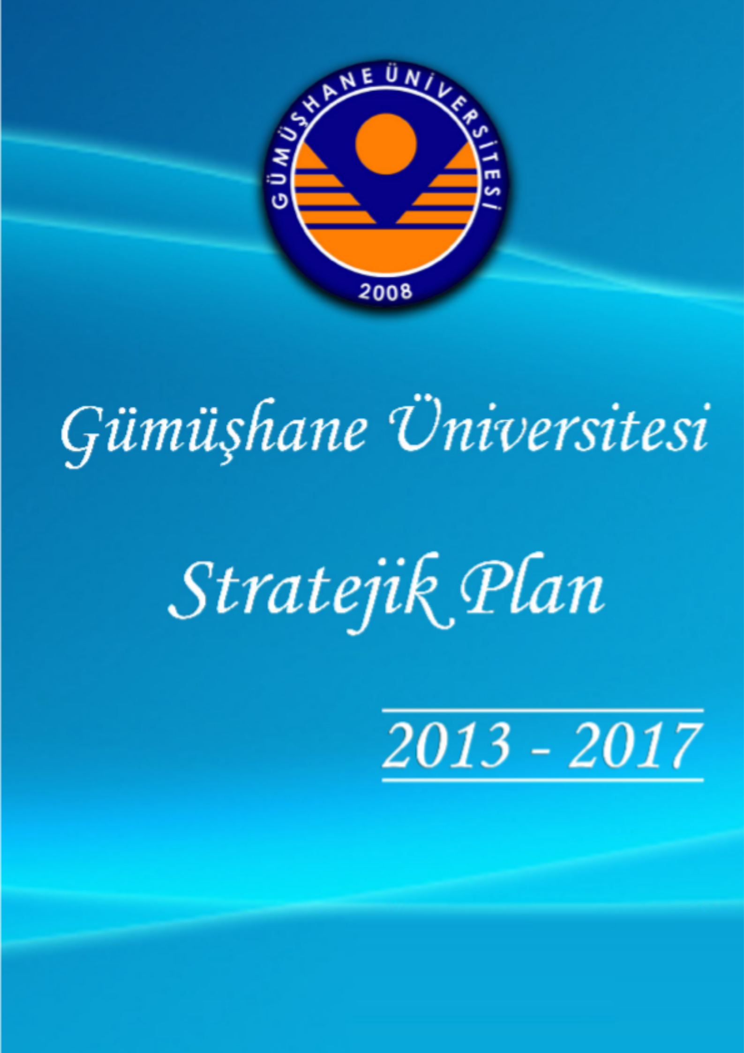




PRESENTATION

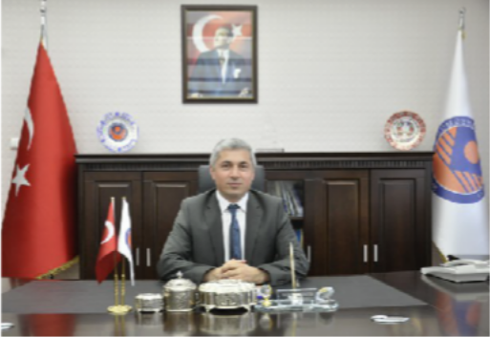
Our university was established in accordance with Article 98 of the Annex to Law No. 2809 on the Organization of Higher Education Institutions, published in the Official Gazette dated 31.05.2008 and numbered 26892.

The most important assets of the information age we live in are knowledge, technology, and a skilled workforce.
Countries that possess science and technology have power and prestige. Universities are the places where science and technology are produced. Therefore, universities are the driving force of economic growth and development. In this context, universities have three fundamental functions. The first, which was the primary function of universities until the 19th century, was to provide a modern higher education to the educated population reaching university age, to prepare them for life, and to train personnel needed by the private and public sectors. However, at the beginning of the 20th century, the function of conducting scientific research also became one of the responsibilities of universities. Thus, the second function became to produce modern technology through scientific work and to offer it for the benefit of society. At the beginning of the 21st century, a third fundamental function was assigned to universities. This is to ensure the use and commercialization of the knowledge and technology produced. In other words, to contribute to society, that is, to create public benefit. Ultimately, universities are also responsible for producing services on behalf of society.

With the enactment of Law No. 5018 on Public Financial Management and Control, a new understanding of public administration has been adopted in our country. The new and important concepts of this understanding are strategic planning, performance-based budgeting, internal control, and internal audit. As a requirement of open and transparent management, the principles of ensuring that the work carried out is in accordance with plans and programs, controlling it, and sharing the results with the public have been adopted. In this context, in line with the strategic management approach, our University's strategic plan has been prepared based on participatory methods.
I would like to express my gratitude to everyone who played a role and took responsibility in the preparation of our university's strategic plan for the period 2013-2017. I would like to thank our institution's staff in advance for their contributions and support during the implementation process, and I wish them success.

Prof. Dr. İhsan GÜNAYDIN, Rector

CONTENTS
DEFINITIONS I
ABBREVIATIONS IV
TABLES, FIGURES, AND GRAPHS VI
TABLES VI
SHAPES VII
GRAPHICS VII
ENTRANCE 1
- GENERAL INFORMATION 3
  - HISTORY AND INTRODUCTION 3
  - AUTHORITY, DUTIES AND RESPONSIBILITIES 5
  - STRATEGIC PLANNING PROCESS AND PARTICIPATION 7
    - STRATEGIC PLANNING PROCESS 7
    - PARTICIPATION 9
- SITUATION ANALYSIS 17
  - PHYSICAL STRUCTURE 17
  - ORGANIZATIONAL STRUCTURE 20
  - INFORMATION TECHNOLOGIES AND TECHNOLOGICAL RESOURCES 28
    - INFORMATION TECHNOLOGIES 28
    - TECHNOLOGICAL RESOURCES 29
  - LIBRARY RESOURCES Error! Bookmark not defined.
  - HUMAN RESOURCES ANALYSIS 31
    - ACADEMIC STAFF 31
    - ADMINISTRATIVE STAFF Error! Bookmark not defined.
  - FINANCIAL SITUATION ANALYSIS 37
    - BUDGET EXPENDITURES Error! Bookmark not defined.
    - BUDGET REVENUES 39
  - STUDENT ANALYSIS 42
  - STAKEHOLDER ANALYSIS 47
    - GATHERING THE VIEWS AND SUGGESTIONS OF STAKEHOLDERS 47
    - IDENTIFICATION AND PRIORITIZATION OF STAKEHOLDERS 48
    - ACCORDING TO THE LEVEL OF INFLUENCE AND IMPORTANCE OF THE STAKEHOLDERS ASSOCIATION 50

  - SWOT ANALYSIS 51
    - INTERNAL ANALYSIS 53
      - STRENGTHS 53
      - WEAKNESSES (AREAS FOR IMPROVEMENT) 54
    - EXTERNAL ANALYSIS (ENVIRONMENTAL ANALYSIS) 55
      - OPPORTUNITIES 55
      - THREATS 56
    - EVALUATION, CONCLUSION AND RECOMMENDATIONS 56
- STRATEGIC DESIGN 59
  - VISION STATEMENT 59
  - MISSION STATEMENT 59
  - OUR SLOGAN 59
  - OUR CORE VALUES 59
  - POLICIES AND PRIORITIES 60
  - STRATEGIC OBJECTIVES AND GOALS 62
- COSTING 79
- MONITORING AND EVALUATION 82
  - MONITORING AND EVALUATION TABLE 83
- BOARDS AND COMMITTEES 84

DEFINITIONS

Academic Units
Gümüşhane University comprises faculties, colleges, vocational schools, institutes, application and research centers, and departments affiliated with the rectorate.

Academic Unit Academic Evaluation and Quality Improvement Boards (UNIT ADEK)These are committees established within academic units to conduct their work.

Sub-Working Committees
These are commissions established by GÜN-AKİDEK with the approval of the rector to conduct research in areas where it is needed.

Gümüşhane University Academic Evaluation and Quality Development Board (GÜN-ADEK)
This board was established in accordance with the "Regulation on Academic Evaluation and Quality Improvement in Higher Education Institutions" adopted by the Gümüşhane University Senate.

Gümüşhane University Academic and Administrative Units Evaluation and Quality Improvement Coordination Office (GÜN-AKİDEK)
The Gümüşhane University Academic Evaluation and Quality Development Board's coordination unit, reporting to the rector, is responsible for planning, organizing, directing, coordinating, training, monitoring, maintaining records, compiling statistics, reporting, and making recommendations regarding quality development activities, in accordance with the decisions taken by the board.

Administrative Units
This refers to the general secretariat, internal audit unit, department heads, legal counsel, and independent business directorates of Gümüşhane University.

Administrative Units Evaluation and Quality Improvement Board
These boards are responsible for improving the quality of administrative services in administrative units, and for establishing, implementing, evaluating, and developing internal control systems.

Self-Assessment
This is the comprehensive, systematic, and regular evaluation of the quality of the university's educational, teaching, research, and administrative activities, as well as its administrative services and institutional quality improvement efforts, by evaluators appointed by the university.

Quality Improvement
The university's goal is the continuous improvement of the quality of its teaching, research, and administrative activities, as well as its administrative services.

Institutional Performance Program
These are plans that indicate the improvement actions to be taken by the university based on internal or external evaluation results, the responsible parties, the measurement method, and the timing.

Mission
It is the organization's reason for existence. It clearly states what the organization does, how it does it, and for whom it does it.

Performance Indicator
Performance indicators demonstrate the extent to which a predetermined goal has been achieved. To ensure measurability, a performance indicator is expressed in terms of quantity, time, quality, or cost. When goals cannot be expressed measurably, performance indicators are included in the strategic plan to address those goals.

Strategic Theme
It describes the service areas and strategic issues in which the organization operates, in line with the vision it aims to achieve.

Strategic Objective
Objectives are a conceptual expression of the results that an organization aims to achieve. They describe the outcomes that will be obtained through the implementation of policies related to the organization's services.

Strategic Objectives
Sub-objectives are specific and measurable goals aimed at achieving the main objectives. Targets are qualitative and quantitative expressions of the anticipated outputs and results within a defined timeframe. Targets must be expressible in terms of quantity, cost, quality, and time.

Strategic Planning Process
Based on internal or external evaluation results, this process involves Gümüşhane University and its units identifying their strengths and weaknesses, as well as the opportunities and threats they face; conducting situational and stakeholder analyses; developing strategies to improve their quality in light of these findings; transforming these strategies into measurable goals; and defining and continuously monitoring performance indicators related to these goals.

Core Values
It refers to the organization's corporate principles, code of conduct, and management style. Defining an organization's core values ​​is crucial for strategic planning because fundamental values ​​and beliefs underlie the organization's vision, mission, and corporate identity.

Vision
It is an ambitious and realistic statement of the future the organization aspires to achieve. Along with the mission statement, the vision statement forms the framework of the organization's plan.

Higher Education In their institutions Academic Evaluation And Quality DevelopmentCommission (YÖDEK)
It refers to the Academic Evaluation and Quality Improvement Commission in Higher Education Institutions, established by the Interuniversity Council.

ABBREVIATIONS

YÖDEK : Commission for Academic Evaluation and Quality Improvement in Higher Education Institutions
DAY ADEK : Gümüşhane University Academic Evaluation and Quality Development Board

DAY OF AKIDEK
: Gümüşhane University Academic and Administrative Units Evaluation and Quality Improvement Coordination Office

SPK (Capital Markets Board of Turkey) today : Gümüşhane University Strategic Planning Commission
DAY IKK : Gümüşhane University Internal Control Commission
DAY PEBK : Gümüşhane University Performance-Based Budgeting Commission
Unit ADEK : Academic Evaluation and Quality Improvement Boards Established in Academic Units

Unit ADEK ACE
: Sub-working teams affiliated with the Academic Evaluation and Quality Improvement Board established in academic units.

GS-IDEK : Administrative Evaluation and Quality Improvement Board Established in the Rectorate and General Secretariat
Unit IDEK : Administrative Evaluation and Quality Improvement Board Established in Administrative Units
GMF : Gümüşhane Faculty of Engineering
GIIBF : Gümüşhane Faculty of Economics and Administrative Sciences
GIF : Gümüşhane Faculty of Communication
GIF : Gümüşhane Faculty of Theology
GEF : Gümüşhane Faculty of Literature
GSYO : Gümüşhane Health College
GTIOYO : Gümüşhane Tourism Management and Hotel Management Vocational School (GBESYO) : Gümüşhane Physical Education and Sports Training College (GMYO) : Gümüşhane Vocational School
GSHMYO : Gümüşhane Health Services Vocational SchoolKADMYO : Kelkit Aydın Doğan Vocational SchoolKSHMYO : Kelkit Health Services Vocational SchoolŞMBMYO : Şiran Mustafa Beyaz Vocational SchoolICKMYO : Irfan Can Köse Vocational School
KMYO : Kürtün Vocational School
TMYO : Torul Vocational School
REK-ÖZK : Gümüşhane University Rectorate (Private Office)
GS-ÖZK : Gümüşhane University General Secretariat (Private Office)
IDB : Internal Audit Unit
SGDB : Strategy Development Department
IMIDB : Department of Administrative and Financial Affairs
KDDB : Library and Documentation Department

BID
: Information Technology Department
YITDB : Construction and Technical Affairs Directorate (ÖİDB) : Student Affairs Directorate (SKSDB) : Health, Culture and Sports Department PDB : Personnel Department
DSIM : Revolving Fund Management Directorate
HM : Legal Counsel
DAY SEM : Gümüşhane University Continuing Education Application and Research CenterDAY ORG : Gümüşhane University Organic Agriculture Application and Research Center (GÜBAP) : Gümüşhane University Scientific Research Projects Coordination OfficeMER LAB : Gümüşhane University Central Research Laboratory DirectorateDAY ENDING : Gümüşhane University Erasmus Coordination Office
DAY FRB : Gümüşhane University Farabi Coordination OfficeDAY BST : Gümüşhane University Bologna Process RepresentationDAY DIO : Gümüşhane University International Relations Office
DAY ABO : Gümüşhane University European Union Office
USA : Department

TABLES, FIGURES, AND GRAPHS

TABLES

Table No. | Explanations | Page No.
Table 1 : | Establishment Dates of Academic Units of Gümüşhane University | 4
Table 2 : | Gümüşhane University Strategic Planning Calendar (2010-2011-2012) | 12
Table 3 : | Total Open Areas of Gümüşhane University | 17
Table 4 : | Total Indoor Areas of Gümüşhane University | 17
Table 5 : | Gümüşhane University Sports Facilities | 18
Table 6 : | Gümüşhane University Public Housing | 19
Table 7 : | Gümüşhane University Internet Connection and Speed | 28
Table 8 : | Number of Computers and Other Technological Resources at Gümüşhane University | 29
Table 9 : | Number of Vehicles and Construction Equipment at Gümüşhane University | 29
Table 10: | Library Resources and Exchange Rates | 30
Table 11: | Number of Academic Staff by Title | 31
Table 12: | Distribution of Academic Staff Positions According to Their Occupancy Rates | 32
Table 13: | Occupancy Rates of Administrative Staff According to Service Classes | 34
Table 14: | Average Age of Gümüşhane University Staff | 35
Table 15: | Estimated Staff Needs of Gümüşhane University by Year | 36
Table 16: | Gümüşhane University (38.90) Budget Realization Table (Economic Level I) | 38
Table 17: | Comparison of Incomes Based on Economic Classification | 39
Table 18: | Number of Master's, Bachelor's and Associate Degree Programs at Our University | 40
Table 19: | Distribution of Students and Academic Staff at Our University According to Field of Study | 41
Table 20: | Number of Physical Spaces Related to Education, Teaching and Research at Our University | 41
Table 21: | Information on Our University's Educational, Teaching and Research Activities | 41
Table 22: | Gümüşhane University Department Student Numbers (2012-2013 Academic Year)* | 42
Table 23: | Number of Foreign Students at Gümüşhane University | 43
Table 24:  Table 25: | Number of Students in the Foreign Language Preparatory Class at Gümüşhane University  Student-to-Faculty Ratio at Gümüşhane University | 43  44
Table 26: | Gümüşhane University Student Quotas and Occupancy Rate | 45
Table 27: | Number of Graduates from Gümüşhane University | 46
Table 28: | Identification and Prioritization of Internal Stakeholders | 48
Table 29: | Identification and Prioritization of External Stakeholders | 49
Table 30: | Associated Internal Stakeholders Based on Their Influence Level and Importance | 50
Table 31: | Associated External Stakeholders Based on Their Influence and Importance | 51
Table 32: | Estimated Cost Table of the Strategic Plan | 77
Table 33: | Estimated Appropriation Distribution for the Period 2013-2017 (Economic Code_2 Level) | 78
Table 34: | Strategic Objectives, Performance Indicators, and Responsible Units | 81
Table 35: | Gümüşhane University Academic Evaluation and Quality Development Board | 82
Table 36: | Gümüşhane University Strategic Planning Commission | 83
Table 37: | Gümüşhane University Academic and Administrative Sciences Evaluation and Quality Improvement Coordination Office | 84

SHAPES

Figure No. | Explanations | Page No.
Figure 1 | : Gümüşhane University Academic Units Organizational Chart | 24
Figure 2 | : Gümüşhane University Administrative Units Organizational Chart | 27

GRAPHICS

Graphic No. | Explanations | Page No.
Graph 1 : | Number of Academic Staff by Title | 31
Graph 2 : | Distribution of Academic Staff Positions According to Their Occupancy Rate | 33
Graph 3 : | Occupancy Rates of Administrative Staff According to Service Classes | 35

ENTRANCE

In the information age we live in, the most important capital is a skilled workforce. The fundamental source of this skilled workforce, which is the basis of development, is knowledge and technology. And where this knowledge and technology are produced, universities are the places where it originates. Students graduating from universities as skilled individuals will undertake important roles in the development of our country. As universities, we must find solutions to provide hundreds of thousands of young people who lack access to higher education with this opportunity.

Universities should achieve brand value by fulfilling their core functions such as higher education, scientific research, and serving the public good. As Gümüşhane University, we strive to provide a modern education to young people who choose our university in the various departments we have established with this awareness. When opening departments and programs within our university, we take into account the needs of the region and the country, as well as the employment potential of our graduates. Although Gümüşhane University was established in 2008 as part of the "A University in Every Province" project, it has rapidly completed its physical infrastructure, academic and administrative organization in a short time, taking significant steps to become one of the successful universities of the future.

The aim is to create a university that is different from other universities in the region, to meet the educational needs of young people waiting to receive higher education, and to become recognized regionally, nationally, and internationally. As a rising star in the Eastern Black Sea Region, our university continues its educational activities with various departments and programs, distinguishing itself with departments and programs not found in other universities in the region. In this context, it has established departments such as mathematics engineering, physics engineering, bioengineering, food engineering, and software engineering, which are very few in our country and are mainly found in large universities. Furthermore, it distinguishes itself by offering departments and programs such as nutrition and dietetics, health management, emergency and disaster management, social services, tourism guiding, tourism management, gastronomy and culinary arts, first aid and emergency care, child development, elderly care, organic farming, mechatronics, occupational health and safety, graphic design, and civil aviation management.

The students we train in these fields will work in research and development in the public and private sectors.
Graduates will have job opportunities in numerous organizations, ranging from development laboratories to the healthcare sector, from the energy sector to the telecommunications sector, from the machinery industry to the defense industry, and from the food, agriculture, and pharmaceutical sectors to the environmental sector. Gümüşhane and its surroundings are highly suitable for organic farming and animal husbandry due to their rich mineral resources, being a pilot region for organic farming, and being one of Türkiye's richest regions for endemic plants. In this respect, our departments and application centers established in these areas will make significant contributions to our regional development and will highlight the difference of Gümüşhane University. Furthermore, our mining departments within the Faculty of Engineering make significant contributions both to the development of this sector in our province, which has a significant mining potential, and to providing our academics and students working in this field with broad application areas. With programs such as organic farming, seed production, forestry, aquaculture, laboratory technician, and veterinary health, the aim is to be a driving force in mobilizing regional resources.

While some large universities' health colleges have only two or three departments in the health field, our health college, with a history of only two years, offers nursing, nutrition and dietetics, and health management departments, as well as midwifery, emergency and disaster management, physiotherapy and rehabilitation, and social services departments. Furthermore, we have applied to the Council of Higher Education (YÖK) to establish some departments that do not yet have undergraduate programs in our country. The nursing, nutrition and dietetics, and health management departments, where education continues, have a better number of academic staff than many university colleges. Compared to other universities' health colleges in our region, we are the only university with departments in nutrition and dietetics, health management, social services, emergency and first aid, and physiotherapy and rehabilitation. The goal is to transform the health college into a faculty of health sciences in the coming years.

In addition to the existing programs offered at our institutes, we plan to open new master's and doctoral programs.

1.
GENERAL INFORMATION

1.1 History and Introduction
Gümüşhane University was established by Law No. 5765 dated 22/05/2008, published in the Official Gazette No. 26892 dated 31 May 2008, entitled "Law on Amendments to the Law on the Organization of Higher Education Institutions and the Decree Law on the Staffing of Teaching Personnel in Higher Education Institutions and the Annexed Tables to the Decree Law on General Staffing and Procedures".

In accordance with Article 98 of the relevant law, a new university has been established in Gümüşhane under the name of Gümüşhane University. This university;
- The newly established Faculty of Communication, under the Rectorate, and the Gümüşhane Faculty of Engineering and the Gümüşhane Faculty of Economics and Administrative Sciences, which were formed by changing their names and affiliations from while they were under the Rectorate of Karadeniz Technical University,
- From Gümüşhane Health Vocational School, which was formed by changing its name and affiliation while it was under the Rectorate of Karadeniz Technical University and is now affiliated with the Rectorate,
- Gümüşhane Vocational School, Şiran Vocational School, and Gümüşhane Health Services Vocational School, which were formed by changing their names and affiliations while they were under the Rectorate of Karadeniz Technical University and are now affiliated with the Rectorate, and Kelkit Aydın Doğan Vocational School, which was formed by changing its name and affiliation while it was under the Rectorate of Erzincan University and is now affiliated with the Rectorate,
- It consists of the newly established Institute of Social Sciences and the Institute of Natural Sciences, both affiliated with the Rectorate.

Since its establishment, Gümüşhane University has continued to grow rapidly; in this context, new faculties, colleges, and vocational schools have been established, and new departments have been opened. Currently, our university continues to grow and develop with two institutes, five faculties, three colleges, eight vocational schools, and five research and application centers.

The establishment dates of the units that were founded under our university, those that were affiliated with our university on May 31, 2008 after their names and affiliations were changed from other universities, and those that were subsequently established under our university are listed below.

Table 1: Establishment Dates of Academic Units at Gümüşhane University

Unit | Date of Establishment | Explanation
Institute of Science | It was established as part of Gümüşhane University with the Establishment Law dated 31.05.2008.
Institute of Social Sciences | It was established as part of Gümüşhane University with the Establishment Law dated 31.05.2008.
Faculty of Engineering | It was established on July 11, 1992, as part of Karadeniz Technical University. | It was transferred to Gümüşhane University on May 31, 2008.
Faculty of Economics and Administrative Sciences | It was established on October 3, 2007, as an affiliate of Karadeniz Technical University. | It was transferred to Gümüşhane University on May 31, 2008.
Faculty of Communication | It was established as part of Gümüşhane University with the Establishment Law dated 31.05.2008.
Seminary | It was adopted by the Council of Ministers on June 7, 2010, and published in the Official Gazette dated July 1, 2010, and numbered 27628.
Faculty of Literature | It was adopted by the Council of Ministers on November 14, 2011, and published in the Official Gazette dated January 3, 2011, and numbered 28162.
Gümüşhane Health College | It was established on November 2, 1996, as an affiliate of Karadeniz Technical University. | It was transferred to Gümüşhane University on May 31, 2008.
School of Tourism Management and Hotel Management | It was adopted by the Council of Ministers on February 1, 2010 and published in the Official Gazette dated February 26, 2010, and numbered 27505.
School of Physical Education and Sports | It was adopted by the Council of Ministers on April 8, 2010 and published in the Official Gazette dated April 28, 2010, and numbered 27565.
Gümüşhane Vocational School | It was established on July 20, 1982, as part of Karadeniz Technical University. | It was transferred to Gümüşhane University on May 31, 2008.
Vocational School of Health Services | It was established on September 10, 1992, as an affiliate of Karadeniz Technical University. | It was transferred to Gümüşhane University on May 31, 2008.
Kelkit Aydın Doğan Vocational School | It was established on July 20, 1982, as part of Atatürk University. On March 17, 2006, it was transferred to Erzincan University. | It was transferred to Gümüşhane University on May 31, 2008.
Kelkit Health Services Vocational School | It was established on September 28, 2003, as part of Atatürk University. On March 17, 2006, it was transferred to Erzincan University. | It was transferred to Gümüşhane University on May 31, 2008.
Şiran Mustafa Beyaz Vocational School | It was established as part of Karadeniz Technical University. | It was transferred to Gümüşhane University on May 31, 2008.
Irfan Can Köse Vocational School | It was established by the General Assembly Decision of the Council of Higher Education dated 21.05.2009.
Kürtün Vocational School | It was established by the General Assembly Decision of the Council of Higher Education dated 21.05.2009.
Torul Vocational School | It was established by the General Assembly Decision of the Council of Higher Education dated 21.05.2009.
GÜ Continuing Education Application and Research Center | It was established by the Council of Higher Education Presidency's letter dated 04.10.2010 and numbered 4904-36299.
GÜ Organic Farming Application and Research Center | It was established by the decision of the Executive Board of the Council of Higher Education dated 30.03.2011.
GÜ First Aid Instructor Training Center | It was established by the decision numbered 69 of the Senate of Gümüşhane University dated 07.12.2012.
GÜ First Aid Training Center | It was established by the decision numbered 69 of the Senate of Gümüşhane University dated 07.12.2012.

1.2
Authority, Duties and Responsibilities
Articles 130 and 131 of the Turkish Constitution relate to higher education. In Türkiye, higher education is primarily regulated by the Higher Education Law No. 2547.

The purpose of the Higher Education Law is to define the aims and principles related to higher education and to regulate, in a comprehensive manner, the organization, operation, duties, powers, and responsibilities of all higher education institutions and their superior bodies, as well as the principles related to education, research, publication, teaching staff, students, and other personnel.

According to Article 12 of the relevant law, the duties of higher education institutions are as follows:

- To conduct education, scientific research, publication, and consultancy at various levels based on secondary education, in a system that is contemporary, based on civilization and educational principles, and in accordance with the needs of society and the principles and objectives of development plans.
- By utilizing its expertise and financial resources rationally, efficiently, and economically, and in line with the principles and objectives of national education policies and development plans, as well as the plans and programs prepared by the Higher Education Council, to train the workforce in the fields and numbers needed by the country.
- To disseminate scientific data that improves the living standards of Turkish society and enlightens the public through speech, writing, and other means.
- To ensure that society is educated, particularly in the areas of industrialization and agricultural modernization, through formal, informal, continuous, and open education.
- To make issues concerning the scientific, cultural, social, and economic progress and development of the country a subject of teaching and research by collaborating with other organizations and making recommendations to public institutions, to present the results for the benefit of society, and to complete the studies and research requested by public institutions and to communicate its opinions and recommendations.
- Within the scope of the education mobilization, measures will be taken to contribute to institutions that provide formal, non-formal, continuous and open education services.

g.
Professions suitable to the development and needs of agriculture and industry in their regions.
To contribute to the training and development of personnel and their knowledge, to carry out, implement and participate in studies and programs that will ensure modernization and increased production in industry, agriculture and health services and other services, to cooperate with relevant institutions in this regard and to make suggestions for solving environmental problems.
h. To produce, develop, use, and disseminate educational technology; i. To develop educational principles for the practical application of higher education; revolving
The objectives are to establish capital enterprises, operate them efficiently, and make the necessary arrangements for the development of these activities.

As a higher education institution, Gümüşhane University fulfills the duties and responsibilities specified in the following laws, decrees, regulations, circulars, directives, and communiqués, in addition to the aforementioned constitutional articles and the Higher Education Law. Furthermore, it fulfills the relevant legal obligations of other laws and the duties and responsibilities stipulated in the secondary and tertiary legislation prepared in accordance with these laws. The main laws are as follows:

Law on the Organization of Higher Education Institutions (2809)
Higher Education Personnel Law (2914)
Decree Law on the Administrative Organization of Higher Education Institutions and Higher Education Supervisory Bodies (124)
Law on Dual Education in Higher Education Institutions, Amendment of Certain Articles of the Higher Education Law No. 2547 and Addition of an Annex Article to this Law (3843)
Law on Granting Scholarships to Higher Education Students (5102)
 Law on Supporting Research and Development Activities (5746)
 Technology Development Zones Law (4691)
 Law on Students to be Sent to Foreign Countries (1416)
 Public Financial Management and Control Law (5018)
 Civil Servants Law (657)
 Law on the Trial of Civil Servants and Other Public Officials (4483)
 Declaration of Assets, Law on Combating Bribery and Corruption (3628)

1.3
Strategic Planning Process and Participation

Strategic Planning Process
Today, as in the rest of the world, our country is experiencing rapid change that profoundly affects social structures and relationships. This rapid change compels all institutions and organizations to take effective measures. This necessity has revealed the need for a comprehensive restructuring in Turkish public administration. Strategic planning has been adopted as a fundamental tool to enable public administrations to provide planned services, develop policies, base these policies on performance-based budgeting, and effectively monitor and evaluate their implementation. The aim of the strategic planning approach is to strengthen policy-making and cost-calculation capacity, develop a goal-based management approach and budgeting, increase responsiveness to beneficiary demands in the provision of public services, and establish accountability.

According to Article 9 of the Public Financial Management and Control Law No. 5018, published in the Official Gazette dated 24/12/2003 and numbered 25326, public administrations are required to prepare strategic plans. In this context, the Gümüşhane University Academic Evaluation and Quality Development Board Directive, adopted by the University Senate's decision dated 06.07.2010 and numbered 24/13, has been published. Considering the contributions that a strategic management and planning approach will provide, it was decided to begin work on preparing the University's first strategic plan following the GÜN-ADEK Decision dated 08.10.2010 and numbered 01.

The strategic planning process in Turkey was initiated with the publication of the Regulation on Procedures and Principles Regarding Strategic Planning in Public Administrations, which contains the methods that public administrations within the scope of Law No. 5018 must apply to prepare their strategic plans, in the Official Gazette dated 26/05/2006 and numbered 26179. Article 8 of the said regulation, titled "Preparation Period and Program," states: "The strategic planning process of public administrations begins with the preparation period." The commencement of the work is announced by the senior management through an internal circular. A strategic planning commission is established under the coordination of the strategy development unit to manage and direct the work. The strategic planning commission creates a preparation program that includes the activities and timeline for the preparation period.

The preparation program includes the following topics.
      - The stages of the strategic planning process,
      - The activities to be carried out in these stages,
      - A timeline showing the dates when the phases and activities will be completed.
      - Responsible boards, units and individuals,
      - Training needs and program,
      - Consultancy services may be needed if required.
      - The costs associated with the planning process, as well as the human and technical resources required.

The "Gümüşhane University Strategic Planning Preparation Program" has been prepared with the aim of contributing to the production of more rational, concrete, results-oriented, and planned services and the creation of sustainable policies by emphasizing institutional responsibility and transparency in the strategic planning efforts of our university. The preparation program aims to clarify all tasks and processes related to strategic planning, the units involved in their implementation, and the determination of the workflow schedule. To this end, the preparation program summarizes the university's strategic planning efforts, the current status, and its legal status and organizational structure according to the Higher Education Organization Law. In accordance with the strategic planning guide for public administrations, the activities during the plan preparation period have been detailed. The needs in the planning process have been identified, and explanations have been provided regarding the implementation, monitoring, and evaluation process of the plan. Furthermore, an organizational chart, a planning process work schedule, strategic plan preparation teams, and a detailed roadmap have been prepared. When creating a preparation program, administrations consider their position in the transition period, human resources, organizational structure, technical equipment, administrative scale, and similar factors. Public administrations are obligated to fulfill all aspects included in the preparation program before beginning to prepare their strategic plans. It has been decided that our university's first strategic plan will be submitted to the Ministry of Development for evaluation by January 31, 2012.

1.3.2 Participation
Article 9 of the Public Financial Management and Control Law No. 5018 states that "Public administrations shall prepare strategic plans using participatory methods in order to establish their future mission and vision, determine strategic objectives and measurable targets, measure their performance in accordance with predetermined indicators, and monitor and evaluate this process, within the framework of development plans, programs, relevant legislation, and the fundamental principles they have adopted." Accordingly, the strategic plan to be prepared is expected to strengthen policy-making and cost-determining capacity, improve goal- and objective-based management and budgeting, and increase responsiveness to beneficiary demands and accountability in the provision of public services.

The Regulation on Academic Evaluation and Quality Improvement in Higher Education Institutions, prepared by the Council of Higher Education, was published in the Official Gazette dated September 20, 2005, and numbered 25942, and entered into force. In this context, the Gümüşhane University Academic Evaluation and Quality Improvement Board Directive, adopted by the University Senate's decision dated July 6, 2010, and numbered 24/13, has been published. The Gümüşhane University Academic Evaluation and Quality Improvement Board (GÜN-ADEK), responsible for the academic evaluation and quality improvement studies of Gümüşhane University, has been established. The number and members of this board have been determined by the Gümüşhane University Senate. The board consists of at least nine and at most eighteen people, including the chairman. Among the board members are at least one vice-rector, one dean, one institute director, one college director, one vocational school director, one research center director, as well as the university general secretary and a student council representative. Representatives from the university's local stakeholders have also been selected as board members. The chairmanship of GÜN-ADEK is held by the Rector of Gümüşhane University, or, in the Rector's absence, by the Vice-Rector who is a member of GÜN-ADEK.

According to Article 10 of the directive, the Gümüşhane University Academic and Administrative Units Evaluation and Quality Improvement Coordination Office (GÜN-AKİDEK) has been established under the Rector's Office to coordinate evaluation and quality improvement studies at our University.

To the AKIDEK Coordinator, in accordance with the decisions taken by the Rector and/or GÜN-ADEK.
The Coordination Office is responsible for planning, organizing, directing, coordinating, training, controlling, maintaining records, compiling statistics, reporting, and making recommendations regarding evaluation and quality improvement activities. It is also responsible for ensuring compliance with the Public Financial Management and Control Law No. 5018 and its secondary legislation, coordinating the University's strategic planning process, conducting all necessary work to evaluate, improve, and approve the quality level of academic and administrative services in line with the institution's strategic aims and objectives, announcing the results, and preparing the institution's internal evaluation report.

According to Article 12 of the Directive and the GÜN-ADEK Decision No. 01 dated 08.10.2010, Unit Academic Evaluation and Quality Improvement Boards (Unit-ADEK) have been established in our Academic Units, as deemed appropriate by GÜN-ADEK and coordinated by GÜN-AKIDEK. The task of these boards is to ensure the coordination of the strategic planning process in their units and compliance with the Public Financial Management and Control Law No. 5018 and its secondary legislation. They are also responsible for conducting and announcing all kinds of work to evaluate academic and administrative services, improve their quality, and approve their quality level in line with the university's strategic plan and objectives.

According to Article 17 of the Directive and the GÜN-ADEK Decision No. 01 dated 08.10.2010, the General Secretariat Administrative Evaluation and Quality Development Board (GS-İDEK) has been established within the Rectorate organization. Administrative Evaluation and Quality Development Boards (Unit-İDEK) have been established in our administrative units, under the supervision of GS-İDEK. The duties of these boards are to coordinate the strategic planning process in administrative units and ensure compliance with the Public Financial Management and Control Law No. 5018 and its secondary legislation; to conduct all kinds of work to evaluate administrative services, improve their quality, and approve their quality level in line with the University's strategic plan and objectives; and to announce the results.

According to Article 11 of the directive, with the approval of the Rector or GÜN-ADEK, GÜN-
AKİDEK may establish subcommittees to conduct specialized studies on specific topics and in the required number. In this context, a "Strategic Planning Commission" has been established under the chairmanship of the Vice-Rector to guide the preparation of the University's strategic plan, to carry out tasks and procedures arising from the strategic planning process, to ensure the flow of information and documents between the committees, and to consolidate the reports produced. This commission may, if deemed necessary, consult stakeholders and gather information from relevant units regarding the subject of the study.

According to Article 11 of the directive and the GÜN-ADEK Decision No. 01 dated 08.10.2010, sub-working groups have been established. The term of office of the group members ends with the preparation of the group's report and its acceptance by the relevant unit or board. Accordingly, separate sub-working groups have been formed for institutional situation analysis (physical structure, organizational structure, personnel numbers, information technologies and technological resources, student numbers, etc.), stakeholder analysis, SWOT analysis, and financial analysis. Furthermore, survey supervisors have been appointed and sub-working groups have been formed to prepare satisfaction surveys that will form the basis of the stakeholder analysis and SWOT analysis, to administer these surveys to students, city residents, academic and administrative staff, and to evaluate and report the results. The results of the satisfaction surveys administered to our students, city residents, and academic and administrative staff are included in the appendices.

Our strategic planning efforts were completed in accordance with the preparation schedule using a participatory method and were discussed and approved at the Senate meeting dated 11.01.2012 and numbered 50. The strategic plan text, recorded with the Senate Resolution, has been sent to the Ministry of Development for evaluation.

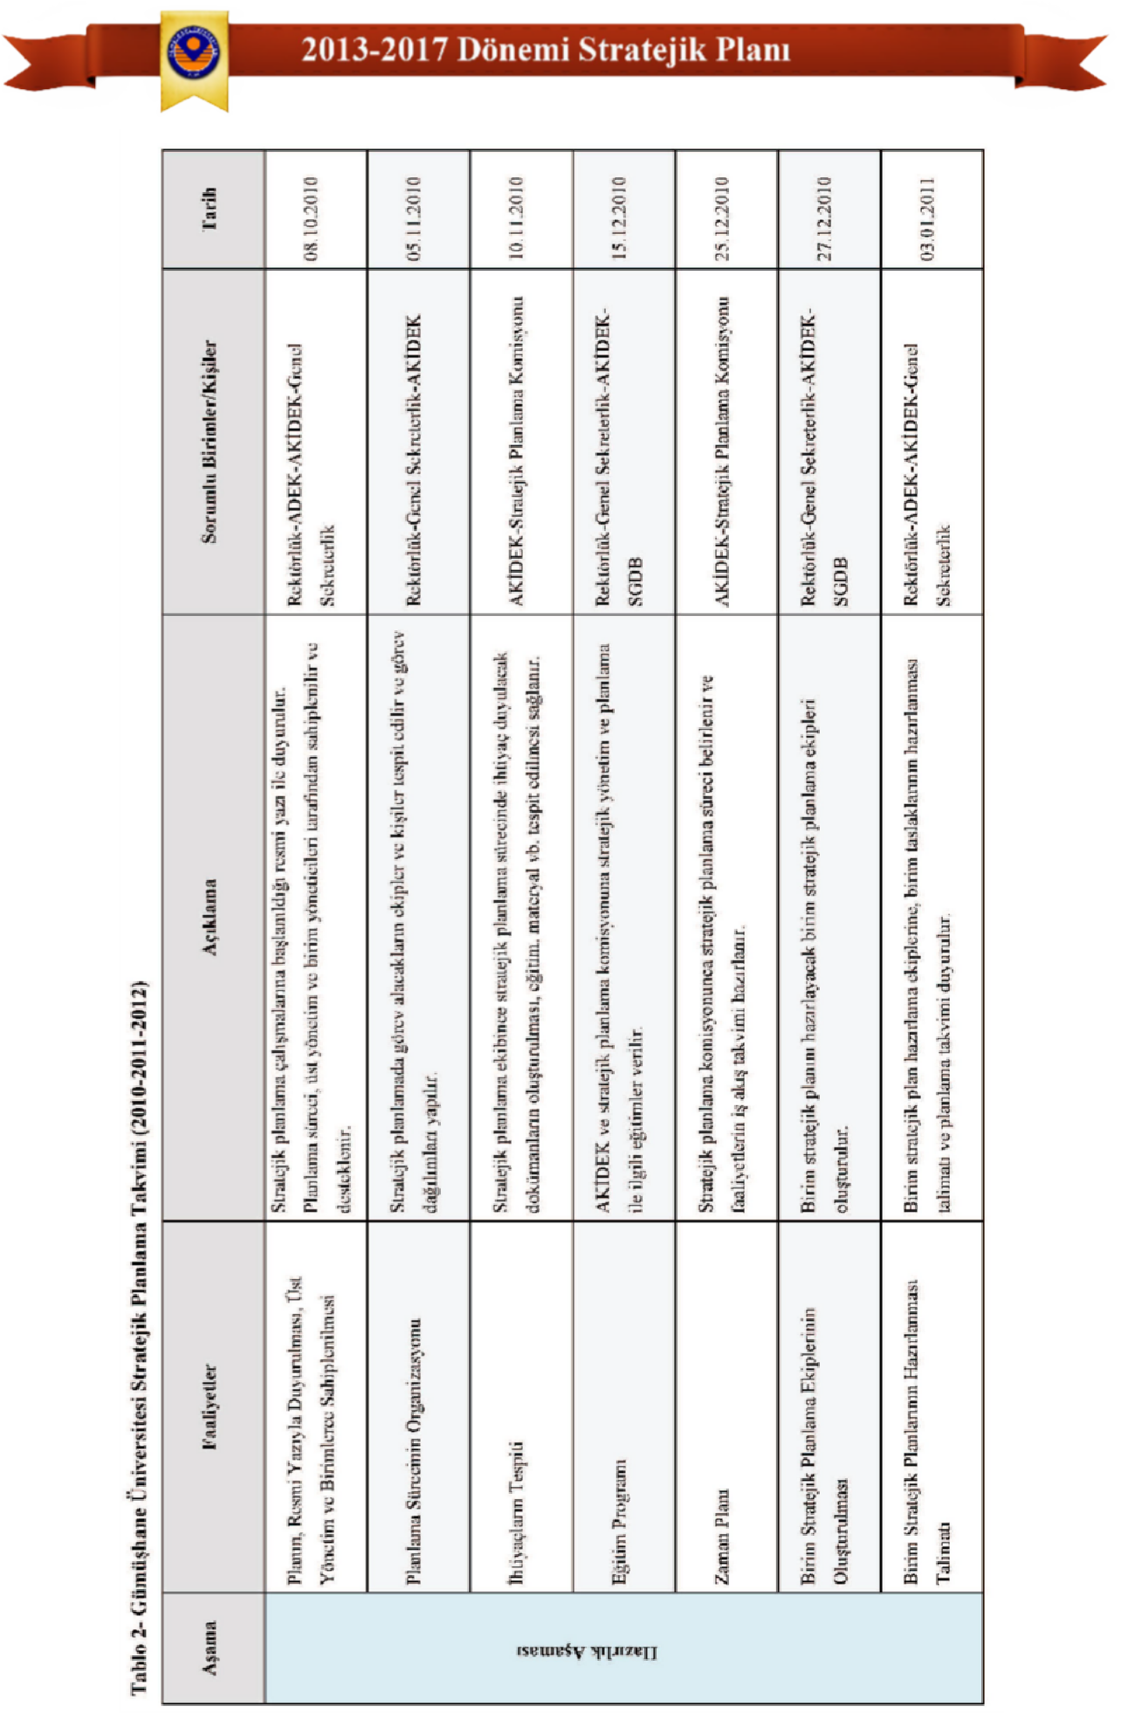

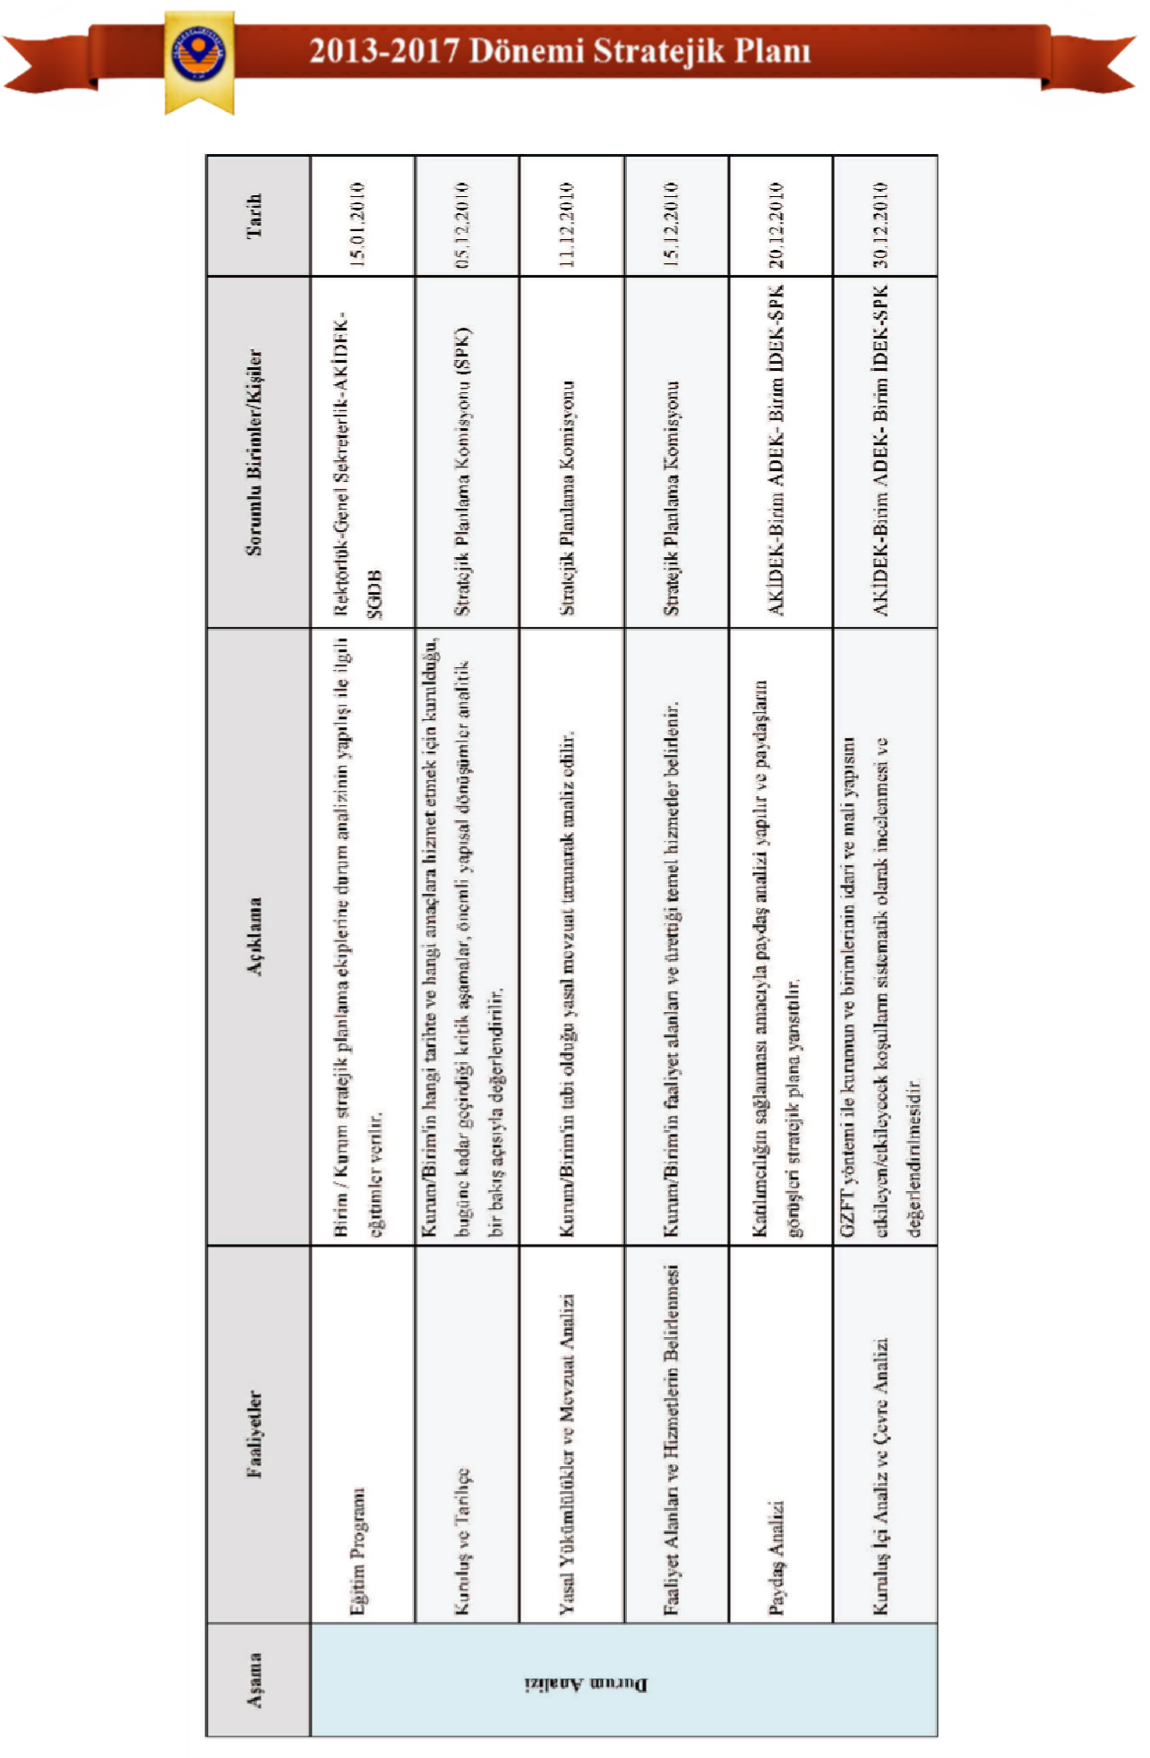

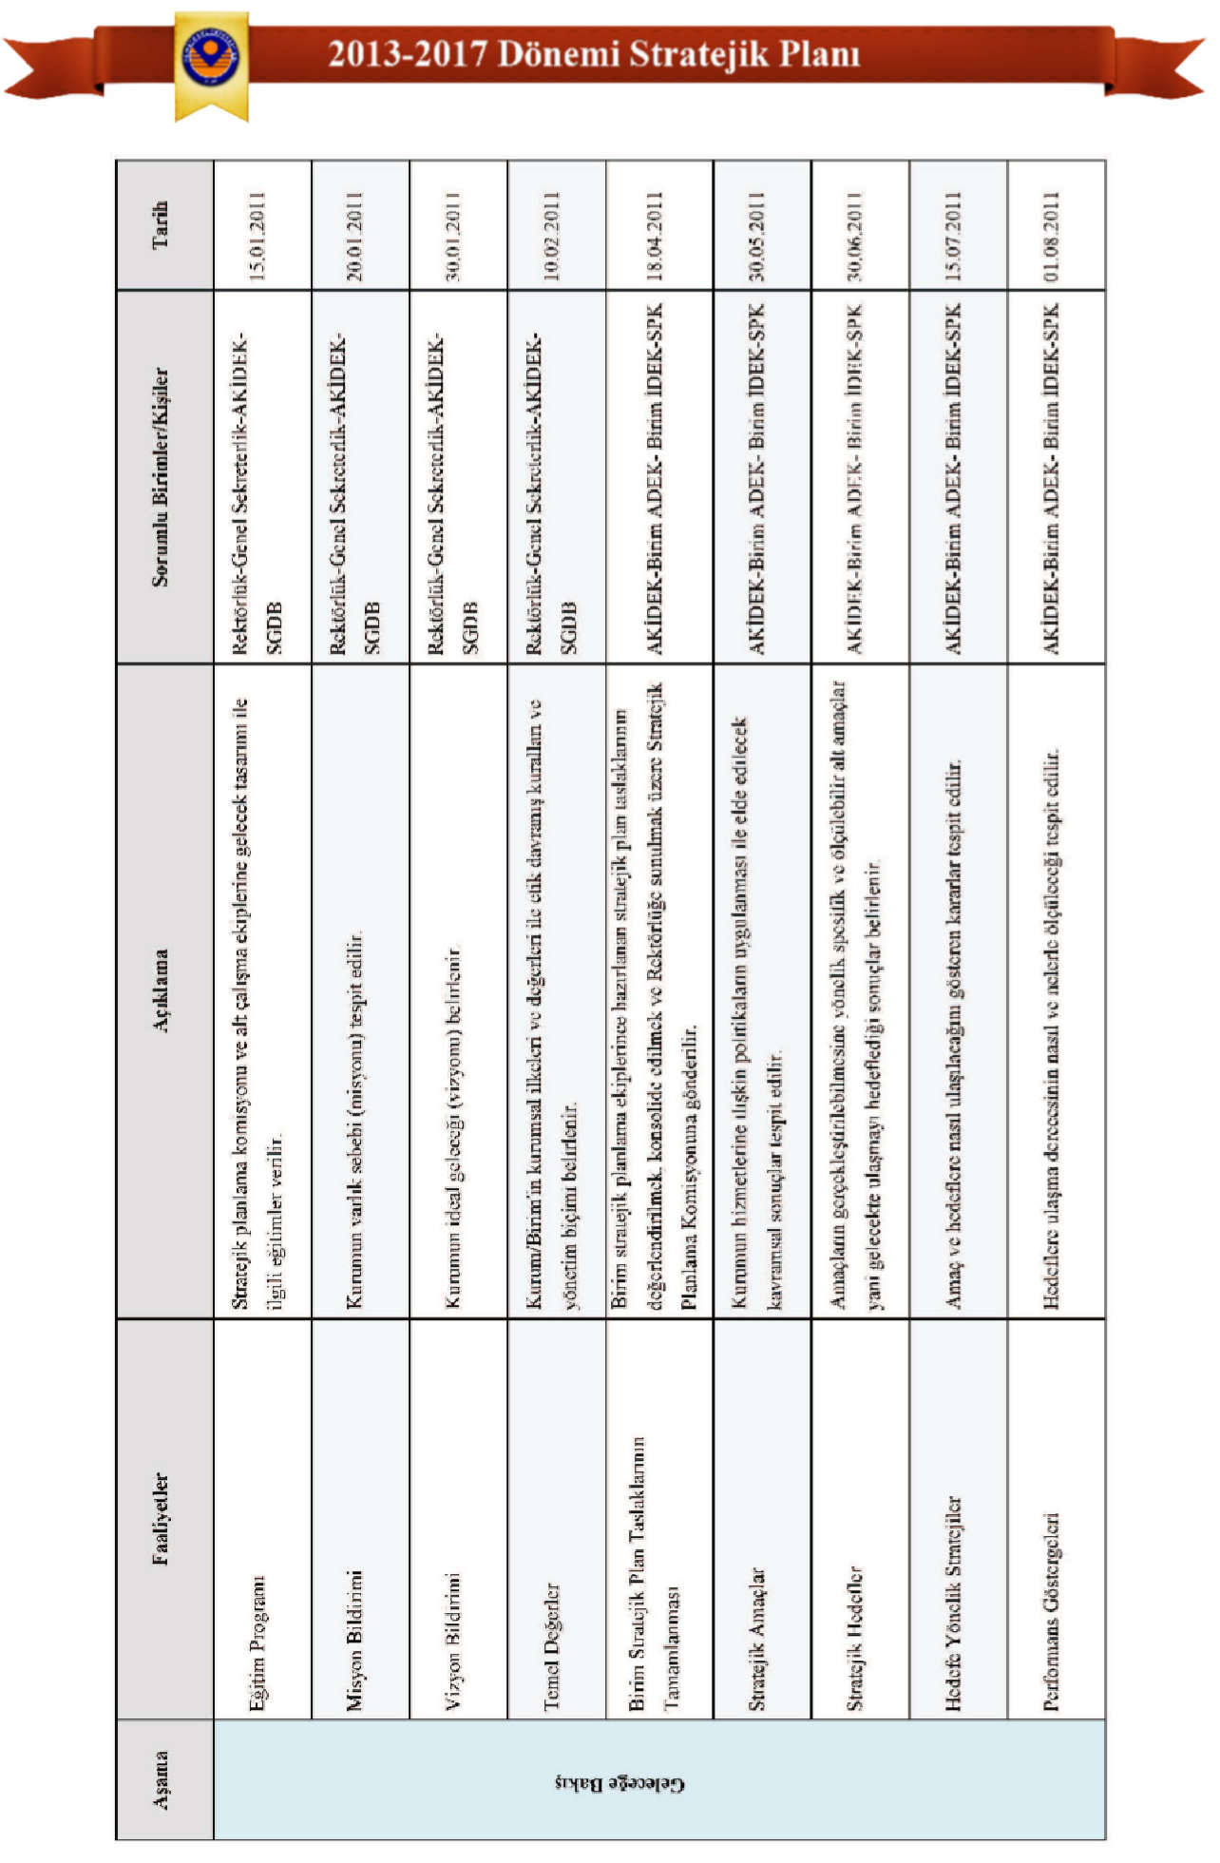

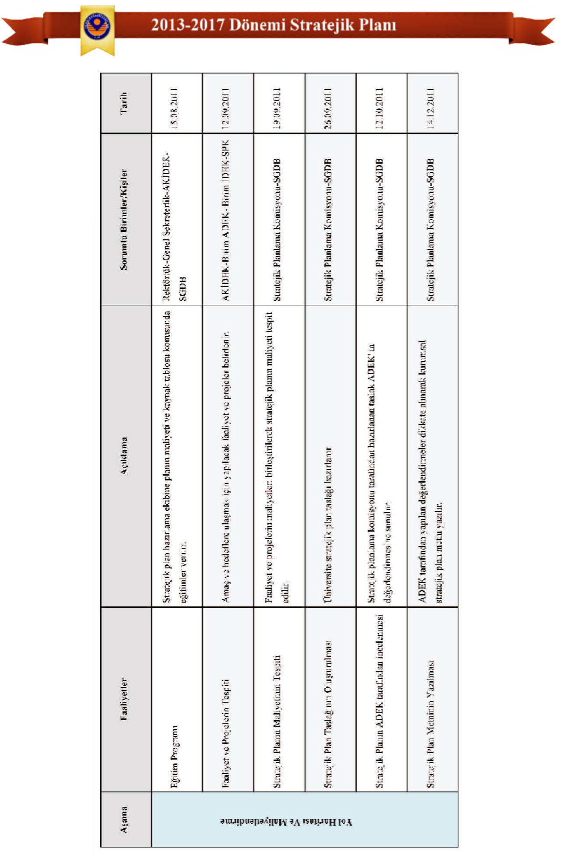

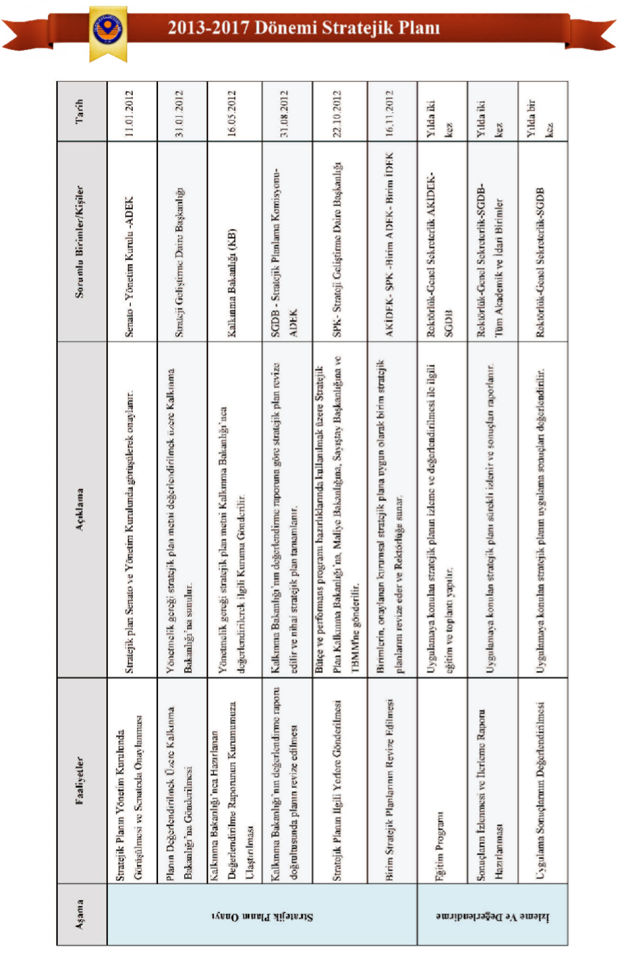

2.
SITUATION ANALYSIS

2.1 Physical Structure
General information regarding the physical facilities of Gümüşhane University is provided in the tables below.

Table 3 - Total Open Areas of Gümüşhane University

Serial Number | Location of the Property | Total Open Area (Square Meters) in 2011 | Total Open Area (Square Meters) in 2012
1 | Gümüşhanevi Bağlarbaşı Campus | 1,515,331 | 1,515,331
2 | Kelkit Aydın Doğan Vocational School Campus | 42,460 | 42,460
3 | Şiran Mustafa Beyaz Vocational School Campus | 5.246 | 5.246
4 | Kürtün Vocational School Campus | 21,895 | 21,895
5 | Irfan Can Köse Vocational School Campus | 7.188 | 7.188
6 | Torul Vocational School Campus | 5.313 | 5.313
7 | Çamlı Köy Location* | 4,700 | 4,700
8 | Kelkit Match Factory Building and Land ** | 87,475 | 87,475
Grand Total |  | 1,689,608 | 1,689,608
* It is allocated for organic farming studies.
**The Kelkit Match Factory Building and Land have been allocated for a period of two years.**

Table 4 - Total Indoor Areas of Gümüşhane University

Serial Number | Location of the Property | Total Indoor Area (Square Meters)
1 | Rectorate Organization Service Building | 3,285.51
2 | School of Health Sciences | 3,669.17
3 | Gümüşhane Vocational School | 7.139.34
4 | Faculty of Engineering Service Building | 21,540
6 | Faculty of Economics and Administrative Sciences and Faculty of Communication Building | 23,164
7 | Physical Education and Sports College Service Building | 7,650
8 | Kelkit Aydın Doğan Vocational School | 8,000
9 | Şiran Mustafa Beyaz Vocational School Service Building | 2,500
10 | Kürtün Vocational School Service Building | 2,400
11 | Irfan Can Köse Vocational School Service Building | 3.150
12 | Torul Vocational School Service Building | 4,000
13 | Institutes/OSYM/AOF Office | 140
14 | Central Dining Hall and Cafeteria | 7,400
15 | Central Research Laboratory Service Building | 1.683
16 | Health Vocational School Annex Building | 5,650
Grand Total |  | 94,416.00
*Based on data from the Department of Construction and Technical Affairs dated October 22, 2012.
Table 5 - Gümüşhane University Sports Facilities *

Gümüşhane University Outdoor Sports Facilities
Serial Number | Location of the Property | Piece | Total Open Area (Square Meters)
Outdoor Gyms
1 | Acrylic Coated Basketball Court (Outdoor) | 1 | 590
2 | Acrylic Coated Volleyball Court (Outdoor) | 1 | 330
3 | Acrylic Kalama Tennis Court (Outdoor) | 1 | 730
4 | Football Field (Outdoor Synthetic Turf Field) | 1 | 5,400
5 | Kelkit Aydın Doğan Vocational School Open Sports Hall | 1 | 420
Total |  | 5 | 7,470
Gümüşhane University Indoor Sports Facilities
Serial Number | Location of the Property | Piece | Total Indoor Area (Square Meters)
Indoor Sports Halls
1 | 1000-Capacity Indoor Sports Hall | 1 | 3.446
2 | Football Field (2 Artificial Turf Fields, 30*50 cm each) | 2 | 3,000
3 | Semi-Olympic Indoor Swimming Pool | 1 | 4,600
4 | Kelkit Aydın Doğan Vocational School Indoor Sports Hall | 1 | 1,500
Total |  | 5 | 12,546
Grand Total |  | 5 | 20.016
*Based on data from the Department of Construction and Technical Affairs dated October 22, 2012.

Table 6 - Gümüşhane University Public Housing

Serial Number | The area where public housing is located. | Piece | Unit Residential Area (Square Meters) | Total Indoor Area (Square Meters)
1 | New Neighborhood Housing Complexes | 16 | 120 | 1920
2 | Old Dormitory No. 6 | 8 | 120 | 960
2 | Old Dormitory No. 6 | 1 | 120 | 120
Subtotal |  | 25 | 360 | 2040
3 | New Housing Complex, Block A | 32 | 120 | 3840
3 | New Housing Complex, Block A, Boiler Room | 1 | 87.85 | 87.85
Subtotal |  | 33 | 207.85 | 3,927.85
4 | New Housing Complex Block B | 32 | 120 | 3840
Subtotal |  | 32 | 120 | 3840
5 | New Housing Complex, Block C | 48 | 120 | 5760
5 | New Housing Complex, Block C (Apartment 49) | 1 | 0 | 461.5
Subtotal |  | 49 | 120 | 6,221.50
6 | Kelkit Adın Doğan Vocational School Dormitories | 6 | 55 | 330
6 | Kelkit Adın Doğan Vocational School Dormitories | 10 | 75 | 750
6 | Kelkit Adın Doğan Vocational School Dormitories | 7 | 125 | 875
Subtotal |  | 23 | 255 | 1955
7 | Kürtün Vocational School Dormitories | 16 | 95 | 1520
8 | Irfan Can Köse Vocational School Dormitories | 4 | 80 | 320
9 | Torul Vocational School Dormitories | 16 | 120 | 1920
Subtotal |  | 36 | 295 | 3760
10 | 32-Apartment Housing Complex, Block D * | 32 | 120 | 3840
10 | Janitor's Apartment | 1 | 87.85 | 87.85
Subtotal |  | 32 | 120 | 3840
Grand Total** |  | 231 | 1,565.70 | 25,672.20
*Based on data from the Department of Construction and Technical Affairs dated October 22, 2012.
* Construction of the 32-apartment housing complex has begun and it will be operational in 2013.
**Out of a total of 231 public housing units, 3 are designated as caretaker (building attendant) apartments, therefore we have 228 actual public housing units..

2.2
Organizational Structure

Academic Structure
The administration and organization of our university are established in accordance with the provisions of the Higher Education Law No. 2547. The governing bodies of the university are the rector, the university senate, and the university board of directors. The duties, powers, and responsibilities arising from the organizational structures in higher education institutions are specified below.

Rector
- Presiding over university boards, implementing the decisions of higher education governing bodies, reviewing and deciding on the proposals of university boards, and ensuring smooth operation among university-affiliated institutions.
- To provide the Interuniversity Council with information about the university's educational, scientific research, and publication activities at the end of each academic year and as needed.
- To prepare the university's investment programs, budget, and staffing needs, after receiving the opinions and suggestions of its affiliated units and the university's board of directors and senate, and to submit them to the Higher Education Council.
- The university may, when deemed necessary, change the assignments of teaching staff and other personnel working in the institutions and units that constitute the university, or assign them new duties.
- To exercise general oversight and control over the university's units and personnel at all levels.
- The university and its affiliated units are primarily responsible for the rational utilization and development of teaching capacity, providing necessary social services to students, taking security measures when necessary, planning and conducting educational, scientific research and publication activities in line with state development plans, principles and objectives, carrying out scientific and administrative supervision and control, delegating these tasks to subordinate units, monitoring and controlling them, and obtaining results.

Senate
- To make decisions regarding the principles of the university's education, scientific research, and publication activities.
- Preparing or commenting on draft laws and regulations concerning the entire university,
- Preparing regulations concerning the university or its units, which will enter into force after being published in the Official Gazette following the Rector's approval.
- Reviewing and deciding on the university's annual academic program and calendar.
- To confer honorary academic titles not subject to examination and to decide on the recommendations of faculty institutions in this regard.
- To examine and decide on appeals against the decisions of faculty boards and institute and college boards affiliated with the rectorate.
- It is responsible for electing members to the university's governing board.

University Board of Directors
- To assist the rector in implementing the plans and programs determined by the higher education governing bodies and the senate decisions.
- To ensure the implementation of activity plans and programs; to review the investment program and the draft budget proposal, taking into account the suggestions of the units affiliated with the university, and to submit them to the rectorate together with their own suggestions.
- To make decisions on matters related to university administration brought forward by the Rector.
- The faculty, institute, and college boards are responsible for reviewing and making final decisions on appeals against their decisions.

The administrative bodies at the Faculty, Institute, and College levels are as follows: Faculty Bodies: Consist of the Dean, who represents the faculty and its units; the Faculty Board, which functions as an academic body; and the Faculty Administrative Board, which assists the Dean in administrative activities. Institute Bodies: Institute Director, Institute Board, and Institute Administrative Board. College Bodies: College Director, College Board, and College Administrative Board. Faculties and colleges are structured as departments, sub-departments (ABD), and scientific departments.

Dean
- To chair faculty boards, implement the decisions of faculty boards, and ensure smooth operation among faculty units.
- To report to the rector at the end of each academic year and whenever requested, on the general status and functioning of the faculty.
- To inform the rectorate of the faculty's funding and staffing needs, along with the justification, and to submit the faculty budget to the rectorate after obtaining the opinion of the faculty's administrative board.
- To exercise general oversight and control over the faculty's units and personnel at all levels.
- The faculty member is primarily responsible to the rector for the rational use and development of the teaching capacity of the faculty and its affiliated units, for taking necessary security measures when required, for providing necessary social services to students, for the orderly conduct of educational, scientific research and publication activities, for the supervision and control of all activities, for monitoring and controlling them, and for obtaining the results.

Institute Director
The institute director performs the duties assigned to the deans within the scope of the institute. In faculties, the faculty secretary reports to the dean, and in institutes, the institute secretary reports to the director.
In colleges and vocational schools, there is a college secretary who reports to the director.

It brings.

College Director
The college director fulfills the duties assigned to the deans in terms of the college.

Department Heads Reporting to the Rectorate
Department of Turkish Language and Literature Department of Atatürk's Principles and History of the Revolution, Foreign Department of Languages, Department of Physical Education, Department of Informatics, Beautiful Department of Arts.

The application and research centers and coordination offices affiliated with the Rectorate of Gümüşhane University are listed below;
- Gümüşhane University Scientific Research Projects (GÜBAP) Coordination Office
- Central Research Laboratory Directorate (MER-LAB)
- Gümüşhane University Continuing Education Application and Research Center Directorate (GÜN-SEM)
- Gümüşhane University Organic Agriculture APPLICATION And Research Central Directorate
- Gümüşhane University Academic Evaluation and Quality Development Board (GÜN-ADEK)
- Erasmus-Farabi Coordination Office
- Bologna Process Representation
- Gümüşhane University First Aid Instructor Training Center Directorate
- Gümüşhane University First Aid Training Center Directorate

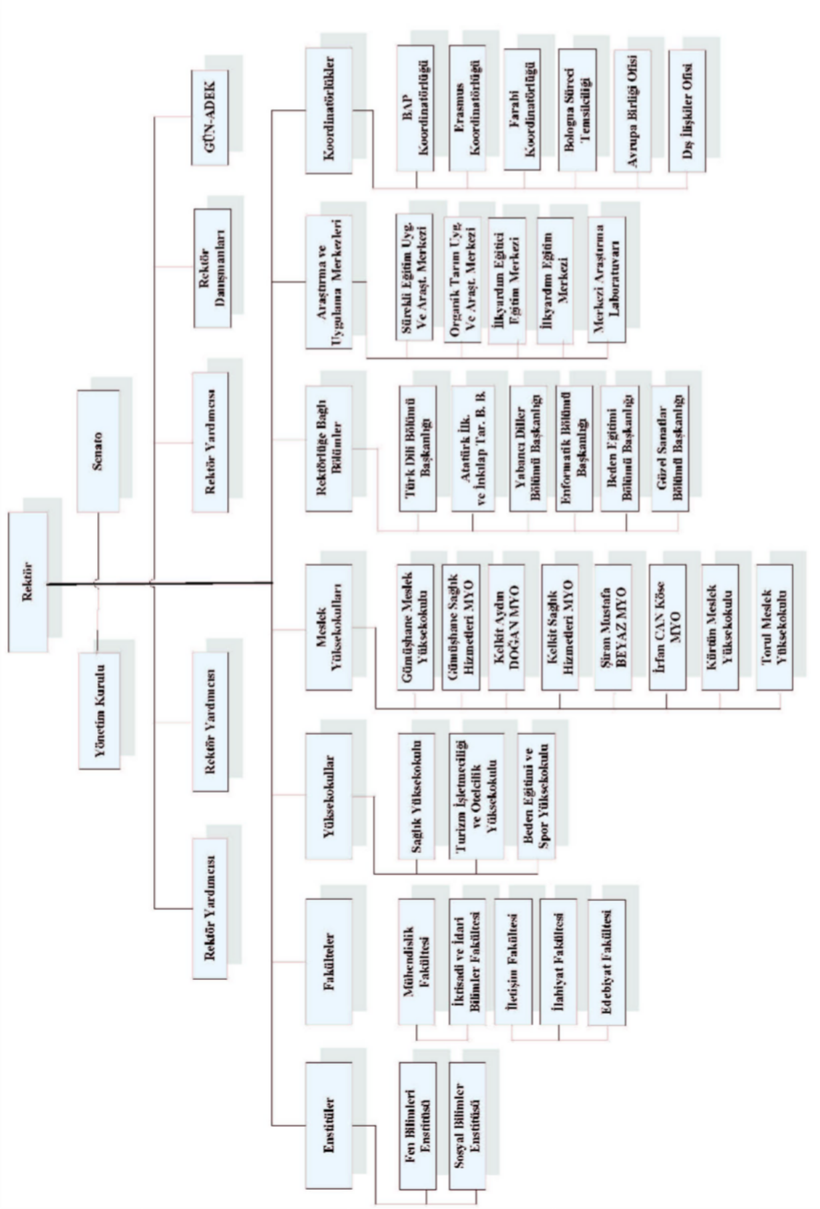

Figure 1 - Organizational Chart of Academic Units at Gümüşhane University

Administrative Structure
The general secretary is at the head of the administrative management within the rectorate organization. Reporting to the general secretary are the deputy general secretary, department heads, legal counsel, and the revolving fund management directorate. The administrative units employ civil servants subject to the Civil Servants Law No. 657.

General Secretariat
The Secretary General is the head of the university's administrative organization and is accountable to the Rector for the organization's functioning.
In addition to his duties as the head of the University's administrative organization, the Secretary General performs the following tasks through the units reporting to him/her:
  - To ensure that the units within the university's administrative organization work efficiently, systematically, and harmoniously.
  - To act as rapporteur in the University Senate and the University Board of Directors without participating in the voting; to ensure that the decisions taken in these meetings are written down, preserved and kept safe.
  - To communicate the decisions of the University Senate and the University Board of Directors to the units affiliated with the University.
  - To make recommendations to the rector regarding personnel to be assigned to the university's administrative organization.
  - To ensure the execution of press and public relations services.
  - To handle the Rectorate's correspondence.
  - To organize the protocol, visits, and ceremonies of the Rectorate.
  - They are obligated to perform similar duties assigned by the Rector.

Internal Audit Unit (Directorate)
The internal audit unit (directorate) is established in accordance with the provisions in the founding laws of public administrations, upon the approval of the Internal Audit Coordination Board; in cases where no such provision exists, it may be established by appointing a director from among the internal auditors, taking into account the needs of the administration.

The administrative units within the General Secretariat are listed below:
- Information Technology Department
- Department of Administrative and Financial Affairs
- Library and Documentation Department
- Student Affairs Department
- Personnel Department
- Department of Health, Culture and Sports
- Strategy Development Department
- Construction and Technical Affairs Department
- Legal Counsel

The other units operating within the Rectorate (Private Office) and the General Secretariat (Private Office) are listed below;
- Rector's Office (Private Secretary)
  - Corporate Communications Coordination
  - OSYM Provincial Examination Center
  - AÖF Provincial Examination Coordination Office
- General Secretariat (Private Office)
  - Office of External Relations (Erasmus-Farabi-Bologna Process Coordination Office)
  - European Union Office
- Gümüşhane University Continuing Education Application and Research Center Directorate
- Gümüşhane University Organic Agriculture Application and Research Center Directorate
- Gümüşhane University First Aid Training Center Directorate
- Gümüşhane University First Aid Instructor Training Center Directorate
- Gümüşhane University Scientific Research Projects (GÜBAP) Unit and Central Research Laboratory Directorate (MER-LAB)
- Revolving Fund Management Directorate
Administrative staff in these units work under the supervision of the General Secretariat.
Corporate Ethics Commission:According to Article 29 of the Regulation on Ethical Conduct Principles and Application Procedures for Public Officials; “In institutions and organizations, an ethics committee consisting of at least three members from within the institution is established by the senior manager to instill and develop an ethical culture, to provide advice and guidance to personnel regarding problems they encounter concerning ethical conduct principles, and to evaluate ethical practices.” The administrative organizational structure is shown in Figure 2.

Figure 2 - Organizational Chart of Gümüşhane University Administrative Units
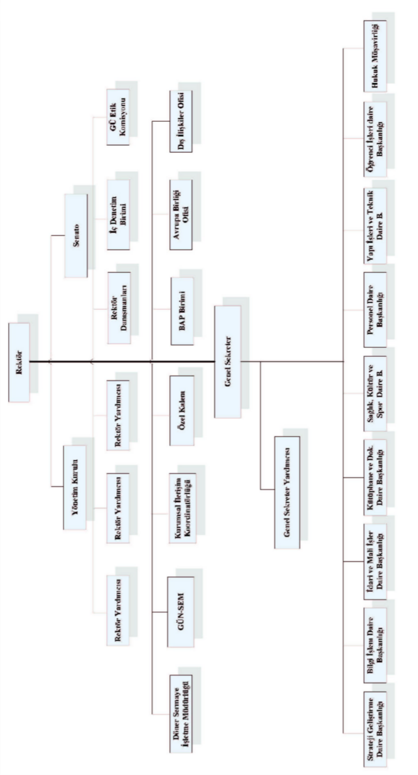

2.3
Information Technologies and Technological Resources

Information Technologies
The information technologies and software used at our university are listed below.
 Accounting Automation System (say2000i)
 Public Accounts Information System (PIS)
 Budget Management Information System (e-budget)
 Rent Tracking System
 BAP Automation Program
 TÜBİTAK Project Transfer Tracking System (TTS)
 State Organization Database (DTVT) System
 Electronic Public Procurement Platform (EKAP)
 SGB.Net Automation Program
 Personnel Automation Program
 Student Automation Program
 Library Automation Program
 Telephone Exchange Management System and Server
 Computer-Aided Design Development Software
 Software for Estimating Costs and Quantity Surveying in Tenders
 Council of Higher Education Common Database (YÖKSİS)
The IT Department's inventory includes computer operating systems, antivirus software, and a total of 14 servers.

Table 7 - Gümüşhane University Internet Connection and Speed

Campus Name | Connection Type | Speed
Gümüşhanevi | Metro Ethernet | 60 Mbps
Kelkit | Metro Ethernet | 5 Mbps
Corner | G.SHDSL | 2 Mbps
Kurd | G.SHDSL | 2 Mbps
Shiran | G.SHDSL | 2 Mbps
Torul | Metro Ethernet | 5 Mbps
Note: All connections are provided through TÜBİTAK-ULAKBİM.

    - Technological Resources
The computers and other technological resources, as well as vehicles and construction machinery used at our university, are listed below.

Table 8 - Number of Computers and Other Technological Resources at Gümüşhane University

Type of Material | Total Number | Type of Material | Total Number
Desktop Computer* | 934 | Portable Computer | 338
Projection | 133 | Printer | 438
Slide projector | 1 | Landline Phone | 574
Cyclops | 2 | Radiotelephone | 27
Barcode Reader | 4 | Mobile Phone | 1
Printing Machine | 6 | Switchboard | 4
Copying machine | 39 | Smart Board | 0
Fax Machine | 11 | Video | 1
Camera | 18 | Microscopes | 35
Cameras | 21 | DVD Player | 2
Televisions | 58 | Power supply | 6
Browsers | 13 | Barcode Printer | 2
Music Systems | 5 | Magnetic Tape Loader | 1
* In addition to the computer resources mentioned above, the Strategy Development Department has 5 more T-Client computers integrated with the Ministry of Finance System.

Table 9 - Number of Vehicles and Construction Equipment at Gümüşhane University

T  Ruler* | Type of Vehicle | 2009 | 2010 | 2011 |  | Total
 |  |  |  |  | 2012 | Total
T-2 | Passenger Car (4x2) | 2 | 2 | 1 | 1 | 6
T-5 | Minibus (Maximum capacity of 15 people including driver - 4x2) | 1 | 1 | 0 | 0 | 2
T-8 | Pick-up truck (Van, for off-road use / 3 and 6 seater) | 0 | 1 | 0 | 0 | 1
T-10 | Minibus (Maximum capacity of 26 people including driver - 4x2) | 1 | 0 | 0 | 0 | 1
T-11a | Bus (Maximum capacity of 27 people including driver - 4x2) | 0 | 2 | 0 | 0 | 2
T-12 | Truck (Chassis-cab fully loaded weight 3501 kg) | 0 | 0 | 1 | 0 | 1
T-15 | Ambulance (Medically Equipped) | 0 | 0 | 0 | 1 | 1
 | Machinery and Equipment (Caterpillar Excavators and Loaders) | 0 | 0 | 1 | 0 | 1
 | Construction Machinery and Equipment (Tractors) | 0 | 0 | 1 | 0 | 1
Total |  | 4 | 6 | 4 | 2 | 16
* T Schedule: A schedule showing the maximum purchase prices of vehicles that institutions will purchase.

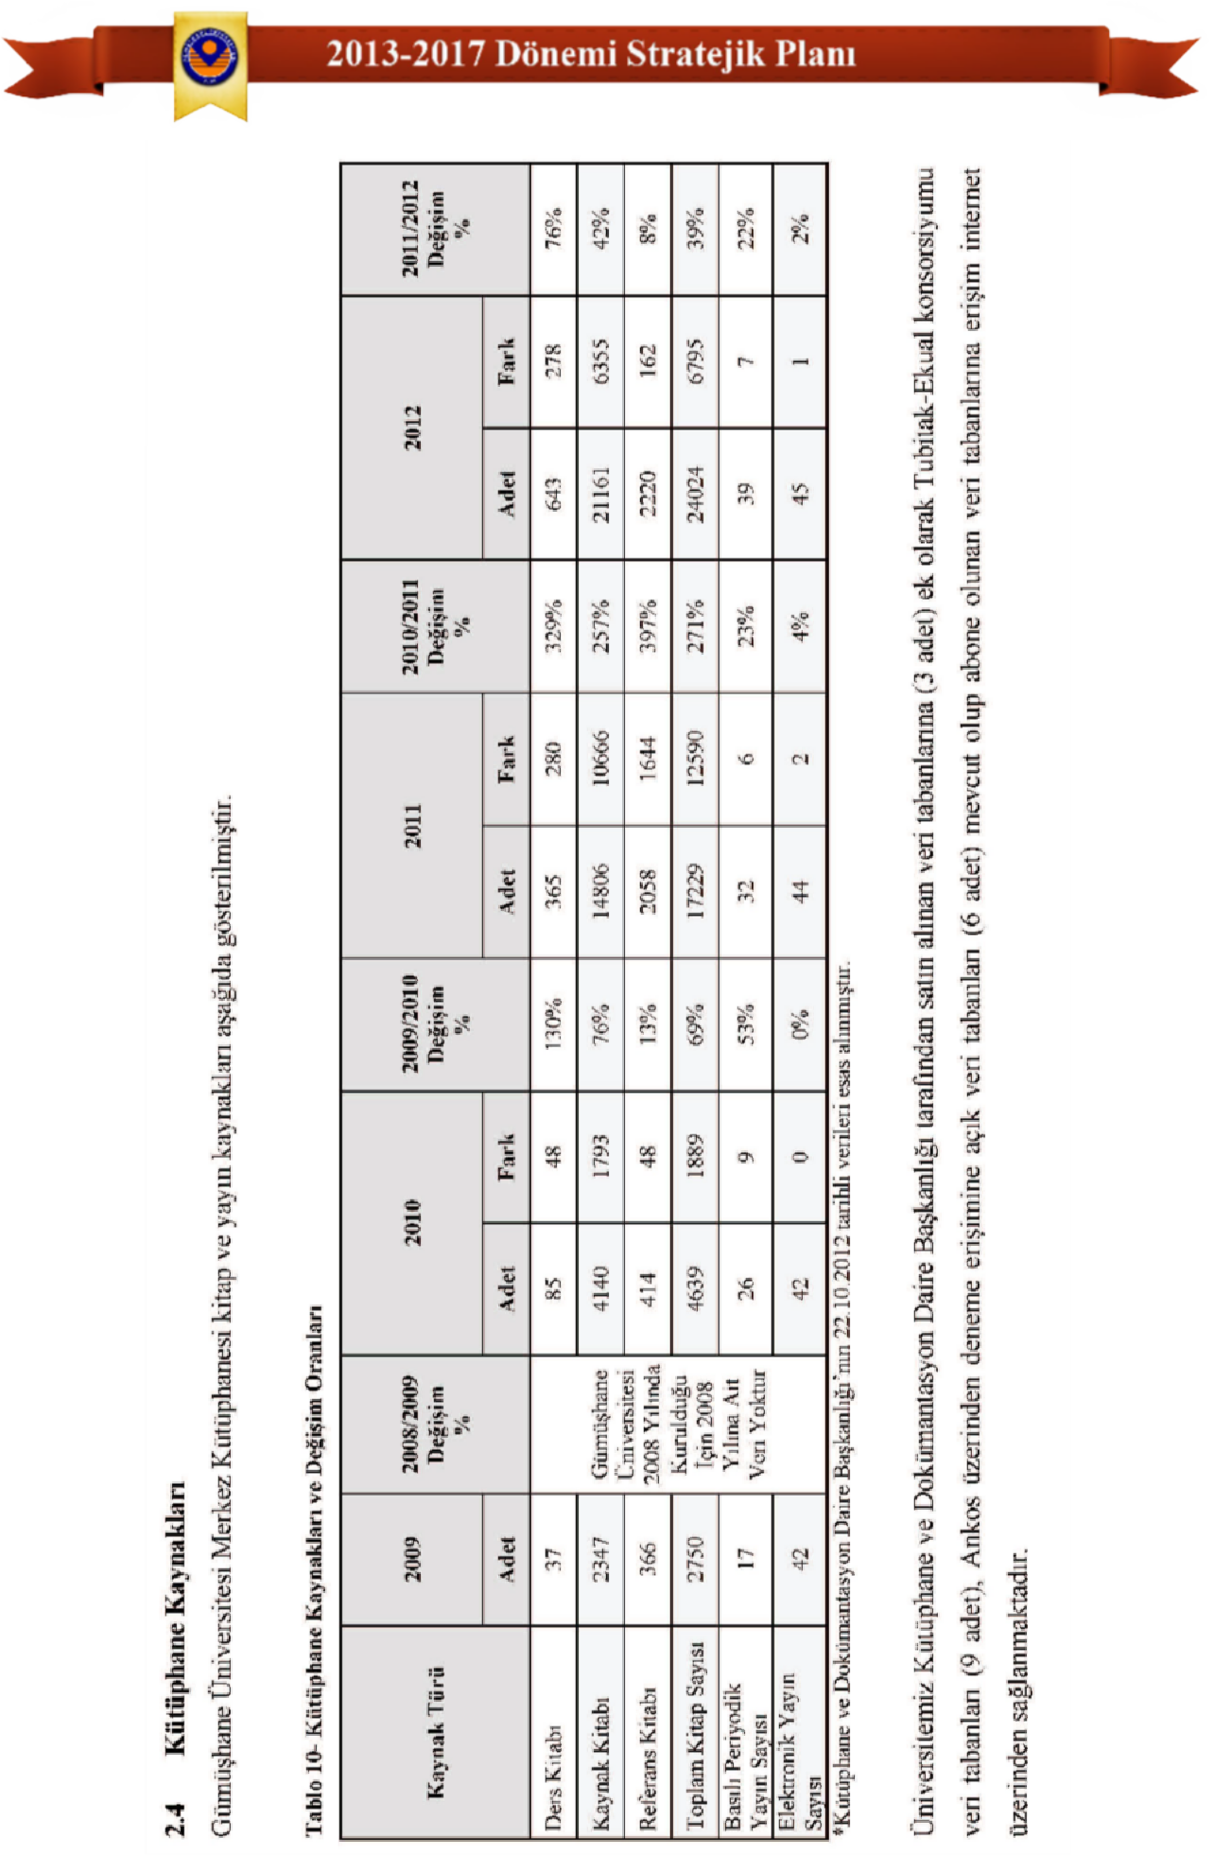

2.4

Human Resources Analysis

Academic Staff
The number of academic staff at our university, categorized by title and year, is shown in the tables and graphs below.

Table 11 - Number of Academic Staff by Title

Title | 2008 | 2009 | 2010 | 2011 | 2012
Professor | 1 | 1 | 1 | 1 | 1
Associate professor | 1 | 1 | 6 | 10 | 13
Assistant Professor | 23 | 65 | 106 | 122 | 143
Lecturer | 31 | 60 | 100 | 126 | 133
Lecturer | 4 | 19 | 25 | 26 | 23
Research Assistant | 13 | 65 | 133 | 141 | 160
Expert | 1 | 2 | 2 | 2 | 2
Total | 74 | 213 | 373 | 428 | 475
*Data from the Personnel Department as of October 22, 2012 was used as the basis.

Graph 1 - Number of Academic Staff by Title
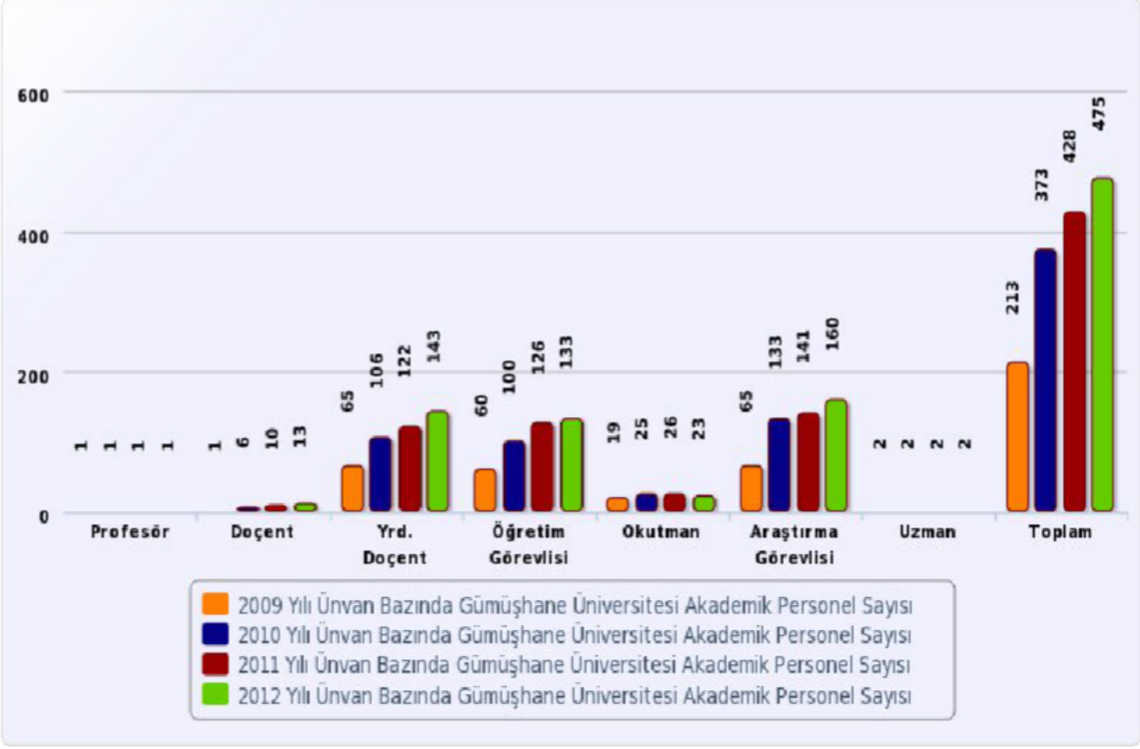

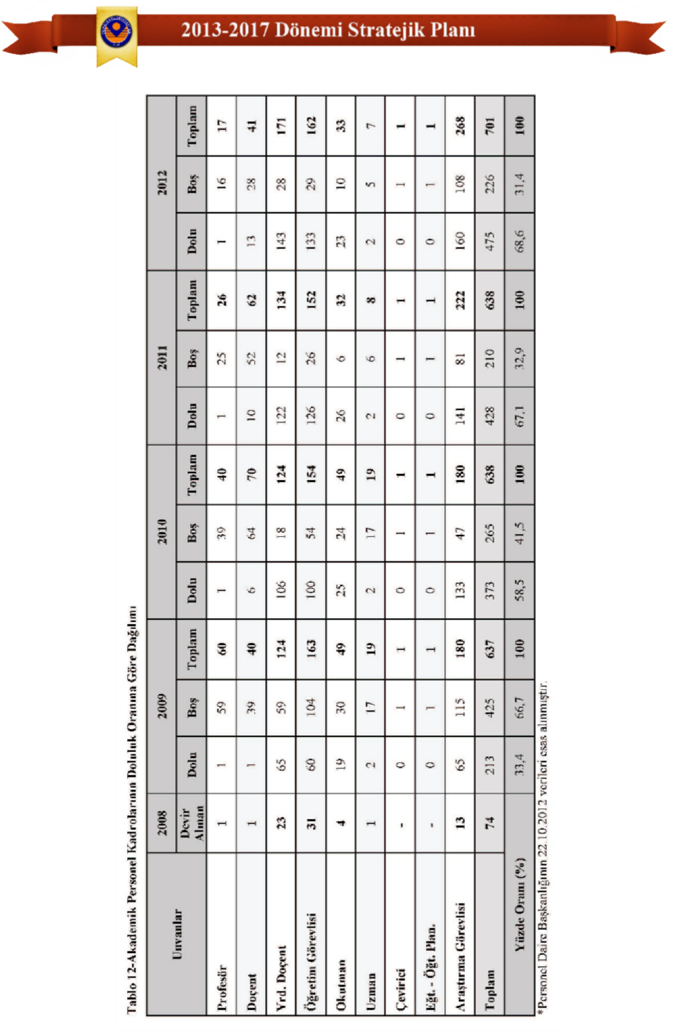

Figure 2 - Distribution of Academic Staff Positions According to Occupancy Rate
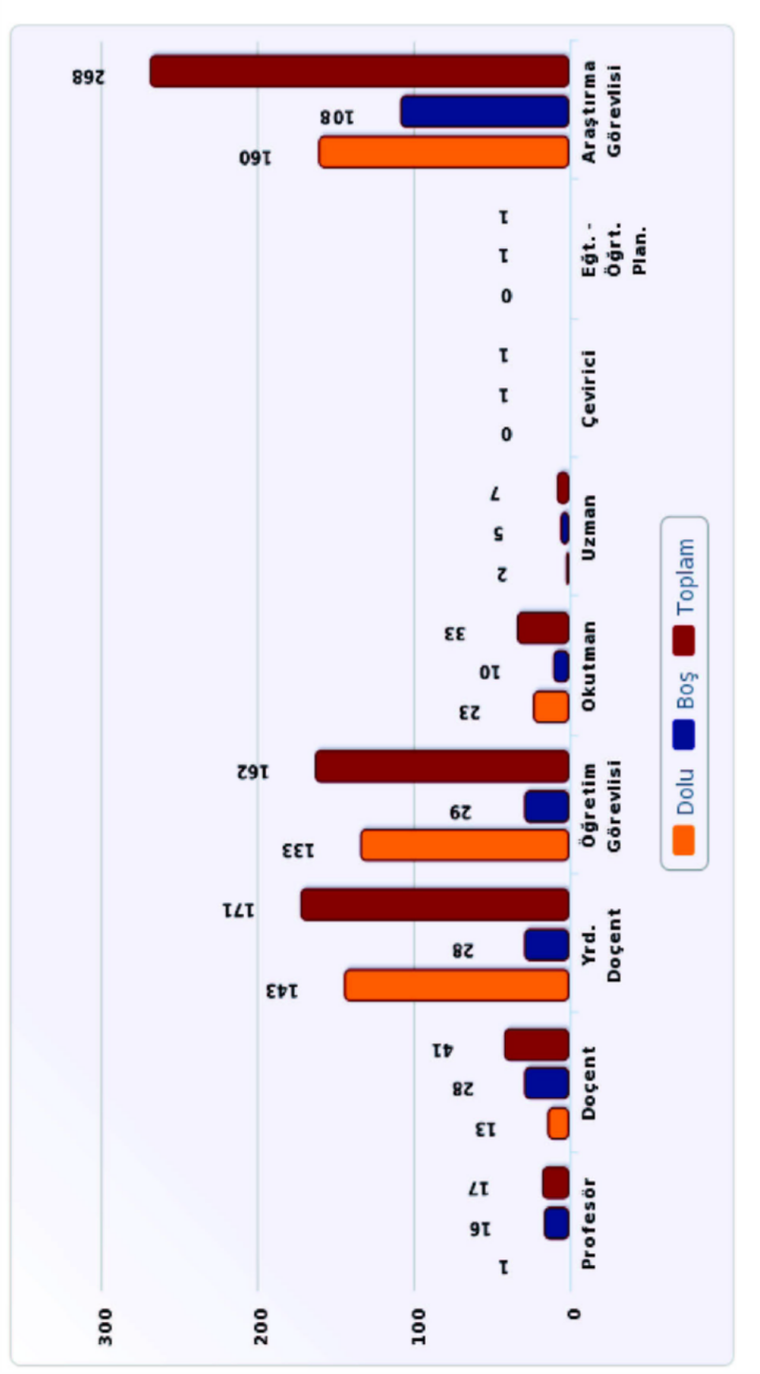

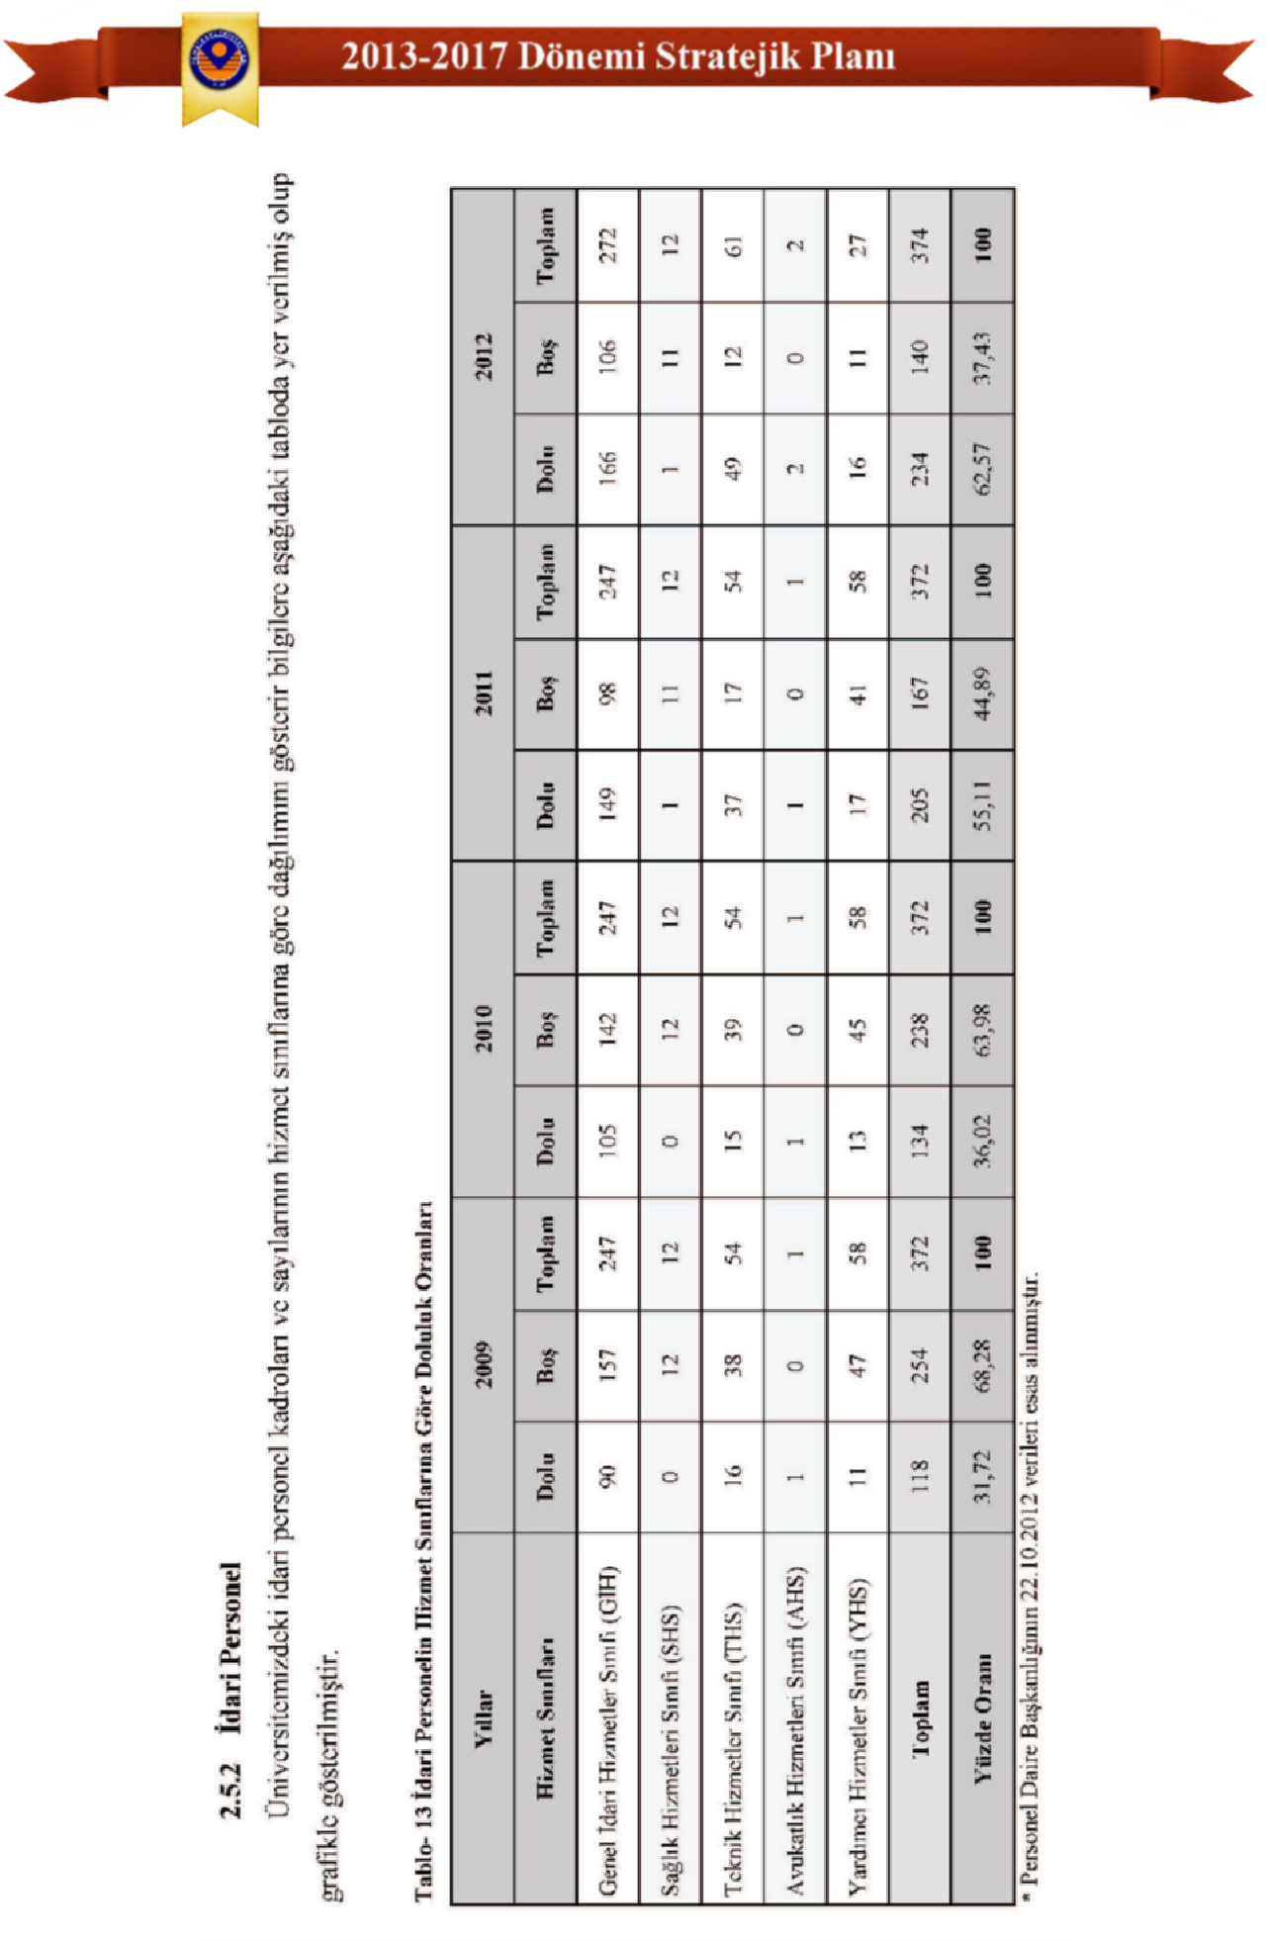

Graph 3 - Occupancy Rates of Administrative Staff According to Service Classes
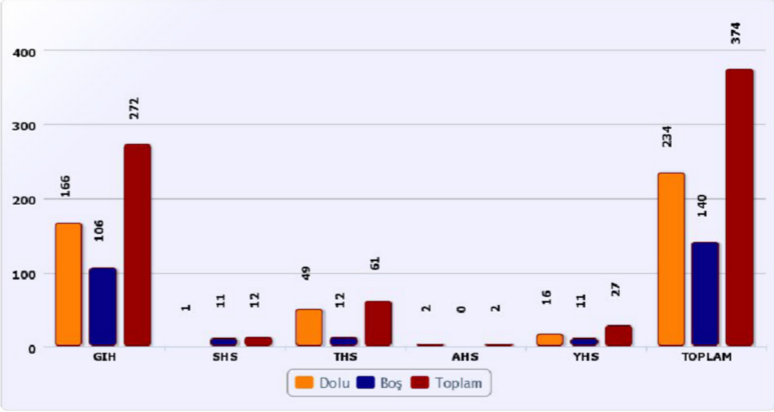

Table 14: Average Age of Gümüşhane University Staff*

Job Title | Number | Average Age
Number of Teaching Staff (Units) | 475 | 35.9
Professor Doctor | 1 | 43.75
Associate Professor | 13 | 41.6
Assistant Professor Doctor | 143 | 38.65
Research Assistant | 160 | 28
Lecturer | 133 | 32.51
Lecturer | 23 | 33.52
Expert | 2 | 34
Number of Administrative Staff (Units) | 234 | 33.82
*Based on data from the Personnel Department dated October 22, 2012.

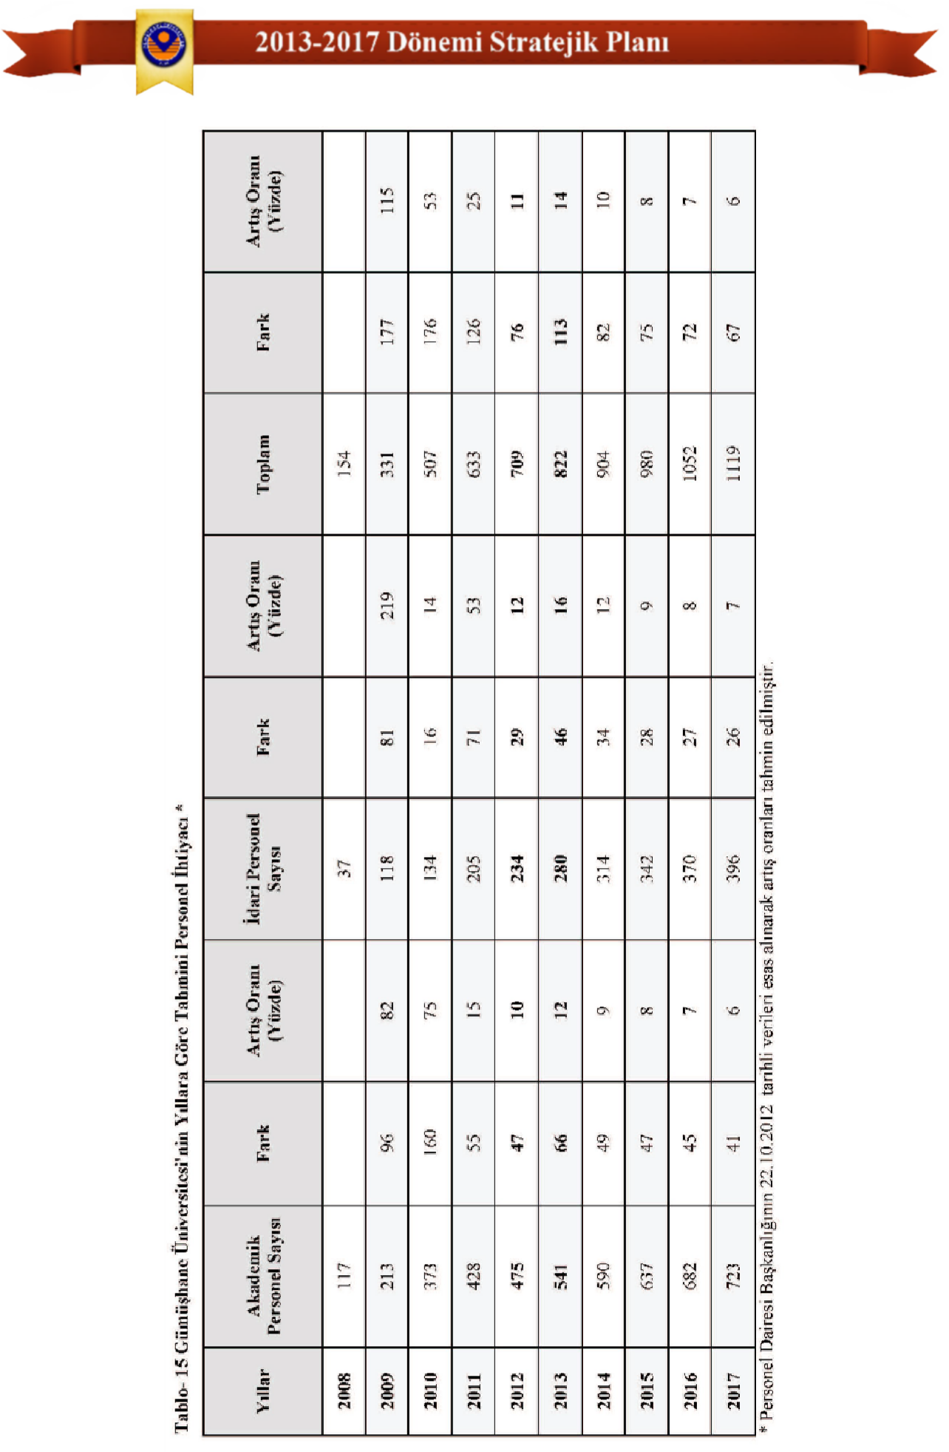

2.6
Financial Situation Analysis
The Public Financial Management and Control Law No. 5018 can be considered the beginning of a new era in the financial management of institutions. Law No. 5018 foresees important regulations regarding the security and transparency of accounting records and financial statements. The security, accuracy, and quality of information throughout the process, from corporate governance principles to accounting records and financial statements, are of paramount importance. The achievement of the strategic aims and objectives of public administrations is closely related to the use of financial resources. The effectiveness of achieving strategic goals largely depends on the provision and use of financial resources under appropriate conditions. Universities, as institutions where societal resources are allocated to education, training, and scientific research services, need to use their financial resources effectively, economically, and efficiently.

Our university is a public institution subject to a special budget, which refers to the public administrations listed in Annex (II) of Law No. 5018, and information regarding its financial resources and year-end performance is given in the tables below.

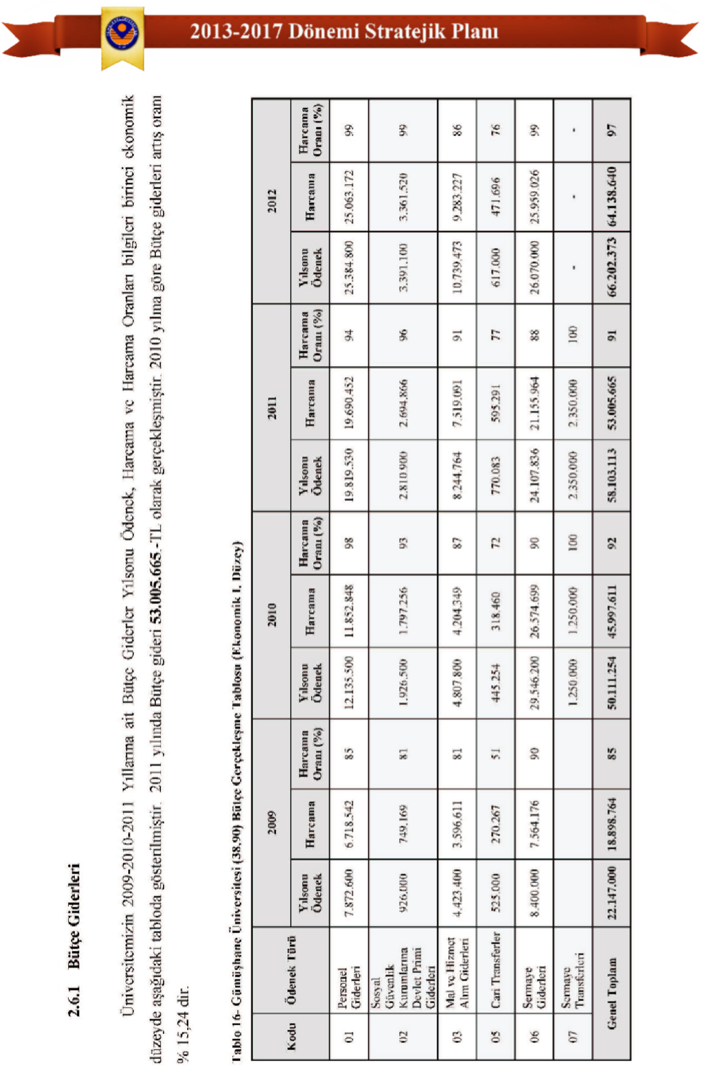

2.6.1

Budget Revenues
Since Gümüşhane University is listed among the institutions with special budgets in Schedule II annexed to the Public Financial Management and Control Law No. 5018, its budget expenditures are financed by income received as treasury assistance and the institution's own revenues. The university's budget revenues are shown in detail in the table below.

Table 17 - Comparison of Incomes by Economic Classification

Economic Codes |  | 2009 | 2010 | 2011 | 2012
(At the Triple Economic Level)
Code | Explanation | Net Collection | Net Collection | Net Collection | Net Collection
03.01.01 | Revenue from Merchandise Sales | 12,740.00 | 39,625.90 | 47,900.00 | 18,534.72
03.01.02 | Service Revenues | 1,732,283.10 | 2,470,291.07 | 3,605,839.19 | 5,027,457.95
03.06.01 | Real Estate Rentals | 34,159.63 | 96,538.38 | 266,985.04 | 444,821.60
03.06.02 | Movable Property Leases | 0 | 0 | 0 | 53,682.52
04.02.01 | Treasury Assistance (Current) | 12,139,000.00 | 11,924,000.00 | 26,747,000.00 | 36,361,000.00
04.02.02 | Treasury Assistance (Capital) | 8,400,000.00 | 28,650,000.00 | 21,000,000.00 | 20,736,000.00
04.04.01 | Conditional Donations and Aid | 0 | 26,692.17 | 677,683.33 | 107,991.37
05.01.09 | Other Interest Rates | 19,113.76 | 45,081.22 | 220,839.42 | 399,276.52
05.02.06 | Other Shares | 0 | 0 | 2,817.22 | 2,839.38
05.02.09 | Other Shares | 5,955.00 | 2,589.80 | 0 | 0
05.03.02 | Administrative Fines | 0 | 6,142.00 | 30,546.74 | 54,089.46
05.03.09 | Other Fines | 0 | 0 | 0 | 1,612.00
05.09.01 | Other Miscellaneous Income | 44,950.27 | 113,451.04 | 141,440.47 | 921,904.05
Grand Total |  | 22,388,201.76 | 43,374,411.58 | 52,741,051.41 | 64,129,209.48
*Based on data from the Strategy Development Department dated 31.12.2012.

The net revenue figures for our university's budget for the fiscal years 2009-2010-2011-2012 are shown in the table above at the third economic level.

Our Main Service Areas and Teaching Status
Our university provides education and training services at the national level in the core fields of engineering, social, humanities and administrative sciences, health sciences, linguistics, theology, and vocational and technical education; conducts scientific research and publications; and carries out academic and scientific activities in national and international arenas in cooperation with stakeholders and practitioners.

INSTITUTES JOBCOLLEGES
Institute of Science Gümüşhane Vocational School
Institute of Social Sciences Gümüşhane Health Services Vocational School
FACULTIES Kelkit Health Services Vocational SchoolFaculty of Economics and Administrative Sciences, Kelkit Aydın Doğan Vocational School, Faculty of Engineering, Şiran Mustafa Beyaz Vocational School
Faculty of Communication Lore Can Köse Vocational School
Seminary Kurd Vocational School
Faculty of Literature Torul Vocational School

COLLEGES
School of Health Sciences APPLICATION AND RESEARCH CENTERTourism Management and Hotel Management College Continuing Education Application and ResearchCentral School of Physical Education and Sports Organic Agricultural Application and Research Center COORDINATORSHIPS First Aid Instructor Training Center
Scientific Research Projects Coordination Center, First Aid Training Center, Erasmus-Farabi Coordination Center Research Laboratory Bologna Process Representation

Table 18 - Number of Master's, Bachelor's, and Associate's Degree Programs at Our University*

Type of Higher Education |  |  | Active | Passive | Total
Postgraduate | Degree | Department | 5 | 0 | 5
Postgraduate | Doctorate | Department | 0 | 0 | 0
Licence |  | Section | 33 | 37 | 70
Associate Degree |  | Program | 57 | 66 | 123
Total |  |  | 95 | 103 | 198
*Based on data from the Student Affairs Department dated October 22, 2011.

Table 19 - Distribution of Students and Academic Staff at Our University by Field of Study

No | Core Field of Science | Student |  | Academic Staff*
No | Core Field of Science | Number | % | Number | %
1 | Linguistics (Philology) Core Field | 0 | 0 | 0 | 0
2 | Theology Core Field | 329 | 3.9 | 30 | 6.23
3 | Vocational and Technical Education Core Field | 4551 | 42.85 | 114 | 24.18
4 | Engineering Core Area | 2077 | 19.55 | 150 | 31.57
5 | Health Sciences Core Field | 1450 | 13.65 | 46 | 9.6
6 | Social, Human and Administrative Sciences Core Field | 2213 | 20.83 | 135 | 28.42
 | Total | 10620 | 100 | 475 | 100
*Based on data from the Student Affairs Department dated October 22, 2012.

Table 20 - Number of Physical Spaces Related to Education, Teaching and Research at Our University

Number of Classrooms | 117 Pieces
Number of Amphitheaters | 7 pieces
Meeting Room | 4 pieces
Number of Offices | 281 Pieces
Computer Laboratory | 19 pieces
Number of Laboratories | 33 Pieces
Total | 461 Pieces

Table 21 - Information on Our University's Educational, Teaching and Research Activities

Activity Type | The year 2011 | Year 2012*
Symposium Congress | 1 | 1
Conference | 22 | 32
Panel | 4 | 4
Seminar | 3 | 3
Technical Visit | 2 | 10
Tournament | 5 | 5
Training Seminar | 26 | 45
Public exhibitions, theatre performances, concerts, etc. | 9 | 9
Scientific Research Projects (TÜBİTAK, KB) | 5 | 30
* The activity information for the year 2012 is based on data as of August 31, 2012.

The departments at our university that offer postgraduate, undergraduate and associate degree education services,
The tables below provide information showing the total number of programs and departments, as well as their distribution by academic unit.

2.7 Student Analysis
The tables below show the number of students studying at the graduate, undergraduate, and associate degree levels at our University, and their distribution by academic unit, according to the mode of instruction (regular formal education - evening formal education) and gender.

Table 22 - Number of Students in Gümüşhane University Units (2012-2013 Academic Year)*

Unit Name | I. Teaching |  |  | Second Education |  |  | Total |  | Grand Total
Unit Name | TO | K | Ball. | TO | K | Ball. | Male | Girl | Grand Total
FACULTIES | 1339 | 959 | 2298 | 1330 | 719 | 2049 | 2669 | 1678 | 4347
Faculty of Economics and Administrative Sciences | 299 | 363 | 662 | 372 | 300 | 672 | 671 | 663 | 1334
Faculty of Engineering | 834 | 320 | 1154 | 721 | 202 | 923 | 1555 | 522 | 2077
Faculty of Communication | 129 | 148 | 277 | 166 | 125 | 291 | 295 | 273 | 568
Seminary | 62 | 104 | 166 | 71 | 92 | 163 | 133 | 196 | 329
Faculty of Literature | 15 | 24 | 39 | 0 | 0 | 0 | 15 | 24 | 39
COLLEGES | 251 | 451 | 702 | 87 | 123 | 210 | 338 | 574 | 912
Health Vocational School | 223 | 435 | 658 | 87 | 123 | 210 | 310 | 558 | 868
School of Tourism Management and Hotel Management | 0 | 0 | 0 | 0 | 0 | 0 | 0 | 0 | 0
School of Physical Education and Sports | 28 | 16 | 44 | 0 | 0 | 0 | 28 | 16 | 44
INSTITUTES | 174 | 54 | 228 | 0 | 0 | 0 | 174 | 54 | 228
Institute of Science | 108 | 29 | 137 | 0 | 0 | 0 | 108 | 29 | 137
Institute of Social Sciences | 66 | 25 | 91 | 0 | 0 | 0 | 66 | 25 | 91
VOCATIONAL COLLEGES | 2259 | 1282 | 3541 | 1012 | 580 | 1592 | 3271 | 1862 | 5133
Gümüşhane Vocational School | 1343 | 550 | 1893 | 580 | 207 | 787 | 1923 | 757 | 2680
Gümüşhane Health Services Vocational School | 66 | 180 | 246 | 59 | 126 | 185 | 125 | 306 | 431
Kelkit Health Services Vocational School | 13 | 62 | 75 | 20 | 56 | 76 | 33 | 118 | 151
Kelkit Aydın Doğan Vocational School | 384 | 165 | 549 | 82 | 34 | 116 | 466 | 199 | 665
Şiran Mustafa Beyaz Vocational School | 100 | 106 | 206 | 65 | 70 | 135 | 165 | 176 | 341
Irfan Can Kose Vocational School | 105 | 67 | 172 | 86 | 41 | 127 | 191 | 108 | 299
Kürtün Vocational School | 120 | 11 | 131 | 108 | 25 | 133 | 228 | 36 | 264
Torul Vocational School | 128 | 141 | 269 | 12 | 21 | 33 | 140 | 162 | 302
Grand Total | 4023 | 2746 | 6769 | 2429 | 1422 | 3851 | 6452 | 4168 | 10620
*Based on data from the Student Affairs Department dated October 22, 2012.

Table 23 - Number of Foreign Students at Gümüşhane University

Units | 2012-2013 Academic Year
Units | Girl | Male | Total
Faculty of Economics and Administrative Sciences | - | 1 | 1
Faculty of Engineering | - | 4 | 4
Faculty of Communication | - | 1 | 1
Seminary | - | 2 | 2
Gümüşhane Health Services Vocational School | 1 | - | 1
Gümüşhane Vocational School | 1 | 1 | 1
Kelkit Aydın Doğan Vocational School | 1 | - | 1
Şiran Mustafa Beyaz Vocational School | - | 2 | 2
Total | 3 | 11 | 14
*Based on data from the Student Affairs Department dated October 22, 2012.

Table 24 - Number of Students in the Foreign Language Preparatory Class at Gümüşhane University

Unit Name | I. Teaching |  |  | Second Education |  |  | Total of I and II Teaching Periods* 100 / Total Number of Students
Unit Name | TO | K | Ball. | TO | K | Ball. | Number of Preparatory Class Students | Total Number of Students | Percentage
Kelkit Aydın Doğan Vocational School | 93 | 31 | 124 | - | - | - | 124 | 665 | 18.64
Seminary | 27 | 54 | 81 | 30 | 51 | 81 | 162 | 329 | 49.24
School of Health Sciences | 24 | 14 | 38 | 14 | 11 | 25 | 63 | 868 | 7.25
(Emergency Aid and Disaster Management)
University Total | 144 | 99 | 243 | 44 | 62 | 106 | 349 | 1862 | 18.74
*Based on data from the Student Affairs Department dated October 22, 2012.
** Ratio of the number of students studying a foreign language to the total number of students (Number of students studying a foreign language x 100 / Total number of students)

Table 25 - Number of Students per Faculty Member at Gümüşhane University

Our Academic Units | The current situation | Strategic Planning Period
Our Academic Units | 2012 | 2013 | 2014 | 2015 | 2016 | 2017
FACULTIES | 33 | 24 | 22 | 21 | 22 | 19
Faculty of Economics and Administrative Sciences | 29 | 25 | 24 | 24 | 19 | 18
Faculty of Engineering | 22 | 23 | 25 | 19 | 19 | 17
Faculty of Communication | 94 | 56 | 39 | 31 | 43 | 35
Seminary | 6 | 6 | 10 | 13 | 13 | 13
Faculty of Literature | 13 | 10 | 11 | 18 | 19 | 25
COLLEGES | 19 | 18 | 19 | 23 | 32 | 38
Health Vocational School | 41 | 21 | 20 | 21 | 23 | 24
School of Tourism Management and Hotel Management | 0 | 20 | 24 | 27 | 36 | 37
School of Physical Education and Sports | 15 | 13 | 13 | 21 | 39 | 55
INSTITUTES | 4 | 4 | 6 | 6 | 6 | 5
Institute of Science | 3 | 3 | 3 | 3 | 3 | 2
Institute of Social Sciences | 5 | 6 | 10 | 9 | 9 | 8
VOCATIONAL COLLEGES | 25 | 19 | 21 | 20 | 20 | 19
Gümüşhane Vocational School | 27 | 18 | 23 | 23 | 23 | 23
Gümüşhane Health Services Vocational School | 18 | 14 | 16 | 17 | 16 | 17
Kelkit Health Services Vocational School | 15 | 13 | 13 | 13 | 14 | 12
Kelkit Aydın Doğan Vocational School | 26 | 21 | 26 | 26 | 26 | 26
Şiran Mustafa Beyaz Vocational School | 18 | 17 | 22 | 22 | 20 | 20
Irfan Can Kose Vocational School | 31 | 17 | 15 | 12 | 11 | 9
Kürtün Vocational School | 44 | 29 | 23 | 22 | 24 | 22
Torul Vocational School | 25 | 27 | 32 | 30 | 29 | 28
Grand Total | 24 | 19 | 19 | 19 | 21 | 21

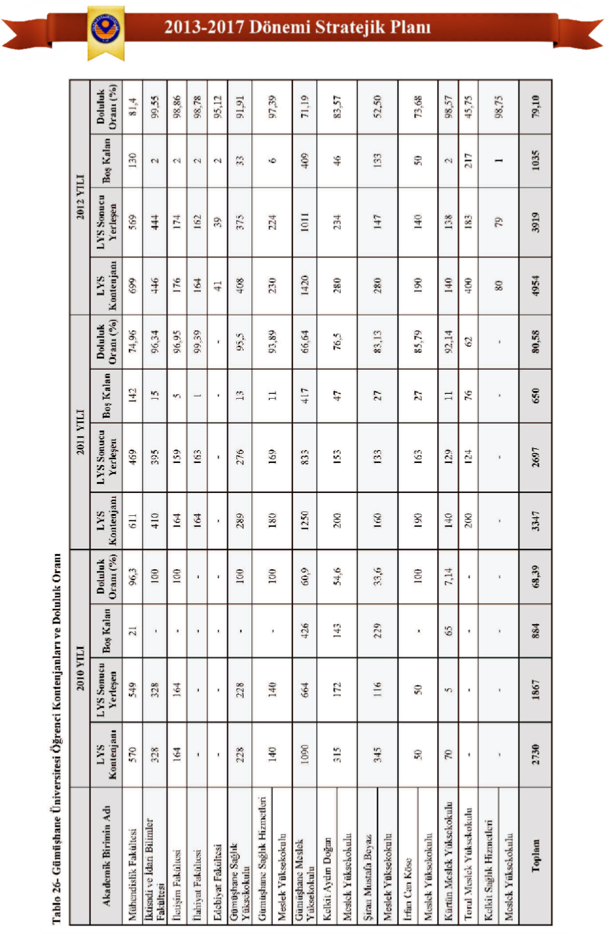

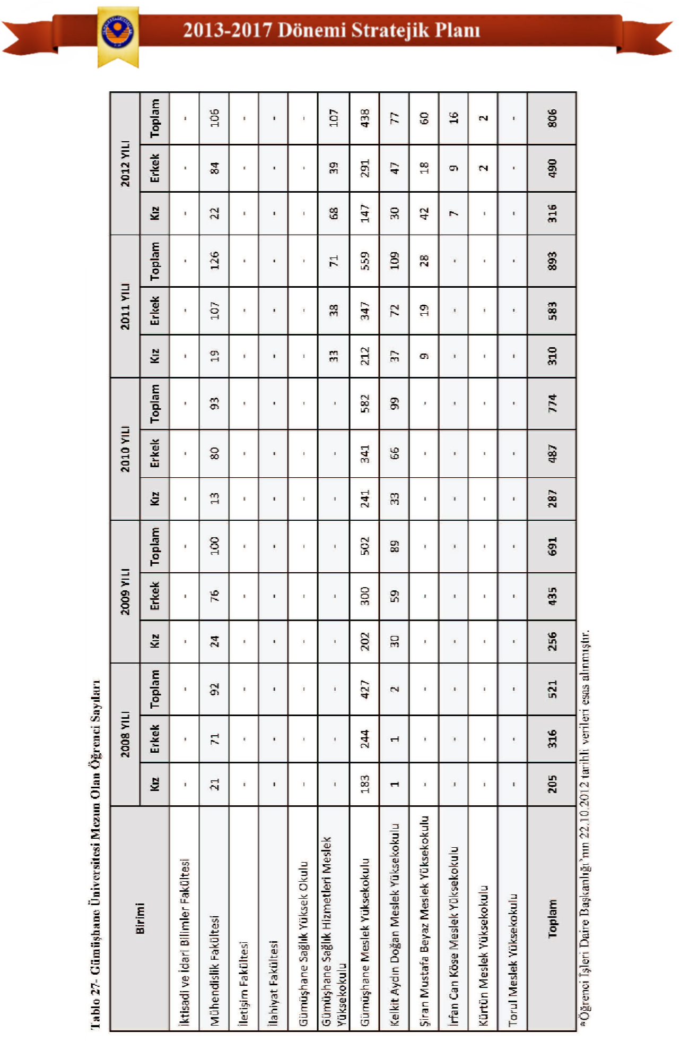


2.8
Stakeholder Analysis

Gathering Stakeholder Views and Suggestions
Within the framework of strategic planning efforts, the identification and analysis of our university's internal and external stakeholders have been initiated, and it has been decided that monitoring, evaluation, control, and analysis will be carried out continuously in accordance with the determined schedule.

Our university has held meetings with internal and external stakeholders during the strategic planning process. Planning training sessions were conducted, and routine meetings were held with the participation of all internal stakeholders, including students, faculty, and administrative staff. In addition to these public meetings, satisfaction surveys were prepared and administered to students, the city's residents, faculty, and administrative staff. Furthermore, strategic planning documents and electronic internal stakeholder information and opinion forms were sent to all units at the expenditure unit level of our university to request feedback. After the documents were sent, commission meetings were held with all units, separately for academic and administrative units, to discuss and share information on how to develop a strategic plan and the management approach to be followed.

Discussions were held with local stakeholders such as the Gümüşhane Governorship, Gümüşhane Municipality, Gümüşhane Chamber of Commerce and Industry, and the Provincial Special Administration to exchange ideas on joint projects. They indicated their willingness to contribute to the organization of educational, cultural, artistic, and sports activities for our University.

In meetings held with our key partners such as the Council of Higher Education, the Ministry of Development, the Ministry of Finance, the Ministry of National Education, the Undersecretariat of Treasury, and the Court of Accounts, information and opinions were exchanged regarding the services and activities of our university; and their support was requested on administrative, financial, and technical matters.

We have contacted many state and private universities in our country and region, informing them that we are open to collaboration. It has been determined that many universities are open to collaboration and contributions.

A certain degree of mutual influence and interaction has been observed, and in addition to this...
It has been revealed that mutual contributions are expected in areas such as joint scientific projects, student activities, central laboratory services, social, cultural and sporting relations, and inter-university information sharing. They have indicated that they can contribute to our University in the organization of joint academic studies and activities related to culture, art and sports.

Identification and Prioritization of Stakeholders
The stakeholders who are directly or indirectly, positively or negatively affected by or who affect our university in terms of its duties, responsibilities, products and services have been identified and are shown in the tables below. Our stakeholders are divided into internal and external stakeholders. They have been prioritized as follows, taking into account their power to influence university activities and the degree to which they are affected by university activities.

Table 28 - Identification and Prioritization of Internal Stakeholders

Stakeholder Name | Stakeholder | Why Stakeholders? | Priority
Students | Internal Stakeholder | Public Service User/Director / Strategic Partner | High
Academic Staff | Internal Stakeholder | Public Service Provider / Strategic Partner | High
Academic Units | Internal Stakeholder | Public Service Provider / Key Partner | High
Administrative Staff | Internal Stakeholder | Public Service Provider / Strategic Partner | High
Administrative Units | Internal Stakeholder | Public Service Producing / Key Partner | High
Those Employed Under Service Procurement Contracts | Internal Stakeholder | Service Production Process Assisting / Key Partner | Middle

Table 29 - Identification and Prioritization of External Stakeholders

Stakeholder Name | Stakeholder | Why Stakeholders? | Priority
Council of Higher Education (YÖK) | External Stakeholders | Guidance, Coordination, Standard Setting, etc. | High
TÜBİTAK | External Stakeholders | Project work, collaborative work, etc. | High
Ministry of Development | External Stakeholders | Top Policy Documents, Plans and Programs, Investments, Expropriation, etc. | High
Ministry of Finance | External Stakeholders | Budget, Financial Management and Control, Accounting Records, Final Accounts, Expropriation, etc. | High
Court of Accounts Presidency | External Stakeholders | Financial Audit, Performance Audit | High
Undersecretariat of Treasury of the Prime Ministry | External Stakeholders | Treasury Assistance | Middle
Ministry of National Education (MEB) | External Stakeholders | Direction, Coordination, Approval, etc. | Middle
Turkish Grand National Assembly | External Stakeholders | Legislature, Government Policies, Planning and Budget. | Middle
Other Universities | External Stakeholders | Collaborative work, etc. | Middle
Gümüşhane Governorship | External Stakeholders | Collaborative work, etc. | Middle
Gümüşhane Municipality | External Stakeholders | Collaborative work, etc. | Middle
Gümüşhane Provincial Special Administration | External Stakeholders | Collaborative work, etc. | Middle
Gümüşhane Chamber of Commerce and Industry | External Stakeholders | Collaborative work, etc. | Middle
Suppliers | External Stakeholders | Service/Product Producer | Middle
Townspeople | External Stakeholders | Benefiting from Economic and Socio-Cultural Outcomes | Middle
Public Sector | External Stakeholders | Users evaluating the outputs or results. | Middle
Private Sector | External Stakeholders | Users evaluating the outputs or results. | Middle
Non-Governmental Organizations (NGOs) | External Stakeholders | Collaborative work, etc. | Middle
Local Press and Media | External Stakeholders | Promotion, Information, Public Relations | Middle
Student Families | External Stakeholders | Public Service User/Financial Partner | Middle
Graduates | External Stakeholders | Evaluating Learning Outcomes Using Public Service | Middle

2.8.3 Stakeholders Correlation Based on Impact Level and Significance
Our internal and external stakeholders have been identified based on their importance and level of impact, taking into account their power to influence the University's activities in terms of its duties and responsibilities, products and services, and the degree to which they are affected by the University's activities.

Table 30 - Relationship between Internal Stakeholders According to Their Influence Level and Importance

Stakeholder Name | Stakeholder | Why Stakeholders? | Priority | Impact Level | Importance Level | Conclusion
Students | Internal Stakeholder | Public Service User/Director / Strategic Partner | High | Weak | First Degree | Protect their interests, ensure their participation.
Academic Staff | Internal Stakeholder | Public Service Provider / Strategic Partner | High | Middle | First Degree | Variable
Academic Units | Internal Stakeholder | Public Service Provider / Strategic Partner | High | Strong | First Degree | Work Together
Administrative Staff | Internal Stakeholder | Key Partner in the Public Service Production Process | High | Middle | First Degree | Variable
Administrative Units | Internal Stakeholder | Key Partner in the Public Service Production Process | High | Strong | First Degree | Work Together
Those Employed Under Service Procurement Contracts | Internal Stakeholder | Service Production To the processAuxiliary / Key Partner | Middle | Weak | 2nd Degree | Variable

Table 31 - Relationship between External Stakeholders According to Their Influence Level and Importance

Stakeholder Name | Stakeholder | Why Stakeholders? | Priority | Impact Level | Importance Level | Conclusion
Council of Higher Education (YÖK) | External Stakeholders | Guidance, Coordination, Standard Setting, etc. | High | Strong | First Degree | Work Together
TÜBİTAK | External Stakeholders | Project work, collaborative work, etc. | High | Strong | First Degree | Work Together
Ministry of Development | External Stakeholders | Top Policy Documents, Plans and Programs, Investments, Expropriation, etc. | High | Strong | First Degree | Work Together
Ministry of Finance | External Stakeholders | Budget, Financial Management and Control, Accounting Records, Final Accounts, Expropriation, etc. | High | Strong | First Degree | Work Together
Court of Accounts Presidency | External Stakeholders | Financial Audit, Performance Audit | High | Strong | First Degree | Work Together
Undersecretariat of Treasury of the Prime Ministry | External Stakeholders | Treasury Assistance | Middle | Middle | 2nd Degree | Variable
Ministry of National Education (MEB) | External Stakeholders | Guidance, Coordination, Standard Setting, etc. | Middle | Middle | 2nd Degree | Variable
Turkish Grand National Assembly | External Stakeholders | Legislature, Government Policies, Planning and Budget. | Middle | Middle | 2nd Degree | Variable
Public Sector | External Stakeholders | Users evaluating the outputs or results. | Middle | Middle | 2nd Degree | Variable
Private Sector | External Stakeholders | Users evaluating the outputs or results. | Middle | Middle | 2nd Degree | Variable
Gümüşhane Governorship | External Stakeholders | Collaborative work, etc. | Middle | Weak | 2nd Degree | Variable
Gümüşhane Municipality | External Stakeholders | Collaborative work, etc. | Middle | Weak | 2nd Degree | Variable
Student Families | External Stakeholders | Public Service User / Financial Partner | Middle | Weak | 2nd Degree | Variable
Graduates | External Stakeholders | Evaluating Learning Outcomes Using Public Service | Middle | Weak | 2nd Degree | Variable
Gümüşhane Provincial Special Administration | External Stakeholders | Collaborative work, etc. | Middle | Weak | Third Degree | Watch
Gümüşhane Chamber of Commerce and Industry | External Stakeholders | Collaborative work, etc. | Middle | Weak | Third Degree | Watch
Townspeople | External Stakeholders | Benefiting from Economic and Socio-Cultural Outcomes | Middle | Weak | Third Degree | Watch
Other Universities | External Stakeholders | Collaborative work, etc. | Middle | Weak | Third Degree | Watch
Suppliers | External Stakeholders | Service/Product Producer | Middle | Weak | Third Degree | Watch
Non-Governmental Organizations (NGOs) | External Stakeholders | Collaborative work, etc. | Middle | Weak | Third Degree | Watch
Local Press and Media | External Stakeholders | Promotion, Information, Public Relations | Middle | Weak | Third Degree | Watch

2.9
SWOT Analysis
SWOT analysis is a method for systematically analyzing the current situation of an institution or province. This approach involves analyzing the strengths and weaknesses, as well as the opportunities and threats faced by the institution/province during planning, and developing future strategies. The internal assessment section of the analysis identifies the strengths and weaknesses of the institution/province in terms of its economic, social, physical, and other infrastructure. The external analysis section examines the impact of environmental opportunities and threats on the institution/province.

The SWOT analysis study utilizes the brainstorming method. Brainstorming is a democratic and participatory working technique used to identify problems and develop solutions by combining the intellectual efforts of a working group within a short time frame to generate as many shared ideas as possible.

The SWOT analysis method was used to identify and analyze the strengths, weaknesses (areas for improvement), opportunities, and threats of our university. The results were evaluated to determine institutional strategic goals and strategies to achieve them. To achieve these strategic goals, coordination with responsible units was established and situation analyses were conducted to identify and formulate the activities to be carried out.

The first part of the SWOT analysis study primarily identified the institution's strengths and weaknesses in sectors such as education, housing, economic and social infrastructure, and transportation, which will shed light on its future goals and the problems it faces. The second part investigated and discussed the opportunities and threats that environmental factors would bring for Gümüşhane University. Strengths and weaknesses were grouped under specific headings, and analyses were conducted on each group based on their importance.

The following general information has been obtained regarding Gümüşhane: the population of the central district is 31,011. There are two student dormitories belonging to the state-run Student Dormitory Institution (KYK) serving higher education students, with a total capacity of 682. The male student dormitory has a capacity of 764 people, and the female student dormitory has a capacity of 1228 people. In addition to these, there are also private student dormitories and hostels.

2.9.1 Organisation Internal Analysis

being

2.9.1.1 Strengths
- The offices and classrooms in the service buildings should be equipped with modern equipment.
- The presence of laboratories and workshops that support hands-on training.
- The excitement of being a newly established university and the desire to succeed.
- Our university has a sufficient number of vacant positions for academic promotions and appointments.

- A guiding and motivating management approach in academic careers.
- There is a commitment to increasing scientific research and publications.
- Faculty members should be open to national and international exchanges and developments, and

They have the potential to monitor innovations
- The high dynamism of the work is a result of the administrative staff being new and young.

being

being

- Encouraging staff participation in training, courses, conferences, and similar events.
- Technological resources are new and the quality of IT services is high.
- Top management adopting a strategic management approach.
- A shuttle service is provided for administrative staff to ensure quick and timely transportation to the university.

2.9.1.2 Weak Directions (Areas for Improvement)
  - Due to our university being new, the number of faculty members (professors, associate professors) is insufficient.
  - The fact that institutionalization and corporate culture have not yet been established
  - Insufficient sense of corporate belonging.
  - Insufficient number of administrative staff and lack of experience among existing personnel.
  - The incomplete construction of sports facilities for students and staff.
  - Lack of social and cultural activities for students.
  - The inability to establish an effective communication network with graduates.
  - The high cost of producing physical structures.
  - The number of public housing units for university staff is insufficient.
  - The institution lacks sufficient social facilities (nursery, park, reading rooms, cinema and theater halls, etc.).
  - Lack of sufficient facilities in the city for R&D activities.
  - Insufficient number of laboratories for foreign language education.
  - Lack of an adequate library service building for access to information and a suitable research environment.
  - The physical environment and canteen services of university canteens are inadequate.
  - Weak communication between academic and administrative staff at the university.

2.9.2 Organisation External Analysis (Environmental Analysis)

being

2.9.2.1 Opportunities
- Increasing the university's economic contribution to the city and raising awareness.
- The operation of mines in the city containing gold, copper, lead, silver, etc.
- The city has natural beauty, biodiversity, and a rich fauna and flora.
- The potential of alternative tourism (winter, highland, mountain, cave tourism, etc.) and nature sports.

- The Harşit River is suitable for environmental landscaping purposes.
- Being a priority province for development and the Gümüşhane Köse Airport project
- Rosehip products, such as fruit leather and dried fruit paste, can be manufactured and patented in Gümüşhane.

belonging
- The use of chemical fertilizers and plant protection products is below the Turkish average.
being
- Köse stated that the presence of significant agricultural lands in Kelkit and Şiran, and the irrigation of the Kelkit River...
an opportunity in terms of organic farming
- The fact that there are efforts to establish a Livestock Organized Industrial Zone in Kelkit, and that organic dairy farming exists in Kelkit.
- The existence of Torul/Kürtün Dam Lakes and the practice of aquaculture in the dams.
- Open to cooperation between civil society organizations, public and private sector organizations in the province.
being
- In terms of training academic staff, from well-established universities in neighboring provinces
the possibility of benefiting

2.9.2.2 Threats
- The accommodation sector in the city is not sufficiently developed.
- The city has a shortage of housing and high rental prices.
- Intercity transportation is only possible by road.
- Inadequate city transit infrastructure and lack of a ring road.
- The fact that the urban transportation problem has not been fully resolved.
- The lack of significant capital accumulation and industrial facilities in the city.
- The lack of social and cultural opportunities in the city.
- The necessity of procuring many materials needed by public institutions and organizations from outside the province.
- The inability to find sponsors (supporters) for scientific activities.
- Universities have very limited influence on general policy regarding the institutional employment of administrative staff.
- Lack of local scholarship opportunities for the student
- There is a lack of part-time job opportunities in the city for students.
- The income level of the students' families is not sufficient.

2.9.3 Evaluation, Conclusion and Recommendations
The SWOT analysis study was coordinated through high-level participation in training sessions and meetings, thanks to the close involvement of the Vice Rector, the Strategic Planning Commission (SPK), unit coordinators, and sub-working teams. The institution's SWOT analysis was conducted using a survey method and by gathering the opinions of all personnel. Participants honestly and objectively analyzed and answered questions about the institution's strengths and weaknesses, as well as its opportunities and threats. The proper completion of the subsequent stages of this process will facilitate the institution's achievement of its future aims and objectives. To address the institution's weaknesses and threats, the top management, who are primarily responsible for resolving these issues, must effectively continue their activities.

According to the analysis method, when comparing the strengths and weaknesses of Gümüşhane University, its strengths slightly outweigh its weaknesses. To further improve this positive gap, collaboration between institutions and units, as well as ongoing improvement activities, are necessary. The identified weaknesses (areas for improvement) should be prioritized and addressed in the institution's future decision-making processes.

Our university, which has not yet completed its structuring phase, has both personnel and...
The university lacks adequate physical and technological infrastructure. Despite these shortcomings, our university strives to fully carry out its academic and administrative activities. Alongside the challenges of being a newly established university, having a young and dynamic staff and a management approach open to development is a significant advantage. If our staffing needs are met and our physical and technological infrastructure deficiencies are addressed, our university will complete its development process quickly and successfully, enabling more effective education and training in the coming years.

Following the SWOT analysis, Gümüşhane University needs to follow the strategies and carry out the related activities listed below in order to achieve its strategic aims and objectives.

 If an organization wants to achieve its future goals and objectives, it must first prepare action plans to eliminate the impact of its weaknesses and implement them quickly. Because inaction will allow weaknesses to rapidly diminish the impact of strengths.
 The organizational solution should prioritize addressing weaknesses that are internal, solvable through management techniques, and not multifaceted. This will prevent time wasted on trying to solve relatively more difficult problems.
 Performance programs and action plans need to be prepared and implemented to further enhance the impact of the organization's strengths.
Monitoring and evaluationThe effectiveness of the aims and objectives achieved in practice, and the progress made, should be analyzed periodically through "progress meetings".
In order for our university to achieve its goals, the number of academic and administrative staff must be increased and working conditions improved.
 As a newly established university, we need to address existing infrastructure deficiencies and complete the necessary landscaping.
 To contribute to the country scientifically, opportunities for national and international projects supported by the Ministry of Development, TÜBİTAK (The Scientific and Technological Research Council of Turkey), and the European Union should be created.
More panels, conferences, talks, tours, and similar events should be organized.


Spaces should be created for social, cultural and sporting activities, and sports facilities should be built.
It should be done.
 Technological equipment should be improved to facilitate and expedite university staff's access to information.
 In order for our university to be among the internationally recognized and preferred universities, we must set goals and carry out our work accordingly.

3.
STRATEGIC DESIGN

Vision Statement Our Vision
"To be one of the top three higher education centers in the Eastern Black Sea Region."

To be a higher education center that trains competent workforce through a nationally/internationally accredited higher education system with scientific and professional qualifications, contributes to scientific knowledge production and scientific indices and technology production, and supports the socio-economic development and progress of Turkey.

Mission Statement Our Mission
Our goal is to support the social, cultural, and economic development of our city, region, and country; to cultivate entrepreneurial, productive, inquisitive, competitive young people with national and international professional qualifications; to produce and disseminate scientific data, knowledge, and technology; and to contribute to regional, national, and global development by collaborating with national and international stakeholders.

Our slogan
A University That Develops and Improves…

Our Core Values
- Universality, Academic Freedom, and Freedom of Expression
- Student-Centered Approach
- Creating Public Benefit
- Embracing Scientific Ethical Values
- Quality and Innovation
- Equal Opportunities and Entrepreneurship
- Ensuring Stakeholder Satisfaction
- Lifelong Learning
- Respect for Human Rights and Social Values
- Commitment to the Rule of Law and Democracy

3.5
Policies and Priorities
Considering Türkiye's Higher Education Strategy, Development Plans, Medium-Term Programs, and the fundamental policies and priorities of our University, our strategic aims and objectives have been determined, along with themes that express our strategic areas, with the goal of becoming one of the leading higher education and science centers in the region.

- Quality will be prioritized in education and training, and universal standards will be taken into consideration.
- The need for faculty members, arising from the increasing number of higher education programs and students, will be met rapidly.
- Practices that expand academic and scientific freedom will be adopted.
- The focus will be on increasing the continuity, usefulness, and quality of scientific activities.
- To enhance institutional identity and culture, a participatory management approach will be adopted, successful students and staff will be encouraged, and open and transparent governance models will be implemented.
- In order to contribute more to regional and national development, the interests of stakeholders will be considered in the development of products and services, and cooperation between the labor market and our University will be increased.
- By taking a leading role in developing university-industry collaboration, we will contribute to the technological development and R&D activities of industrial organizations in the region.
- In order to strengthen our R&D-based production capabilities, our application and research centers and central research laboratories will be developed.
- With an entrepreneurial spirit, we will play the highest role in activities that benefit the region, and we will develop and support flexible, development-oriented projects that resonate with the community.
- Participation in project work on national and international platforms that will enable the transformation of generated knowledge into technology will be encouraged.
- International programs aimed at increasing student and faculty exchange and mobility in higher education will be closely monitored. Mutual exchanges of faculty and students will be facilitated by utilizing grant programs that enable foreign students and scientists to participate in teaching activities at our university.
- Existing administrative and human capacity will be improved in terms of quality and quantity in line with the strategic management approach, and programs will be organized to adapt the management culture to the new structure. Measurement, monitoring, and evaluation processes will be developed within the framework of strategic planning and performance programs.

13.
Financial management necessary for strengthening management responsibility at our university,
Efforts will be made to ensure the effective implementation of internal control and internal audit activities.
14. In order to achieve financial autonomy and a competitive structure, the University's financial resources will be diversified and increased.

3.6 Strategic Aims and Objectives

Theme 1 EDUCATION AND TRAINING
Objective 1 To improve education in terms of quantity and quality.
Strategic Objective 1 To increase the number of departments/programs at our university and to admit students to the programs that will be opened.
Strategic Objective 2 To improve the quality of education and training at our university,
Strategic Objective 3 To increase the number of research projects and publications of our university.

Theme 2 SCIENTIFIC RESEARCH AND DEVELOPMENT
Objective 2 To develop the infrastructure and resources to produce knowledge and technology.
Strategic Objective 4 Improving the infrastructure of laboratories
Strategic Objective 5 Aincreasing the number of research and development projects

Theme 3 PUBLIC CREATING BENEFITS AND COLLABORATION
Objective 3 To create public benefit, to improve relations with industry and business.Strategic Objective 6 To support social, cultural, economic, and scientific activities focused on serving the community.

Theme 4 PHYSICAL CONSTRUCTION AND ENVIRONMENT
Objective 4 To improve physical infrastructure, landscaping, and facilities.
Strategic Objective 7 To increase the total amount of indoor space,
Strategic Objective 8 Completing the landscaping and infrastructure of the main campus.

Theme 5
INSTITUTIONALIZATION AND CORPORATE SATISFACTION
Objective 5 To provide fast, effective, and high-quality service in order to ensure institutionalization and corporate satisfaction.
Strategic Objective 9 Increasing the quantity and quality of our corporate human resources.
Strategic Objective 10To carry out services related to the procurement of corporate goods, materials and services quickly, effectively and with high quality.
Strategic Objective 11Improving corporate information and document management and conducting legal services. Strategic Goal 12: Increasing corporate information technology and library resources and improving service quality.
Strategic Objective 13To increase the number of institutional services and improve the quality of services for our students and staff.
Strategic Objective 14 To increase the recognition of our University both domestically and internationally.

Theme 6 FINANCIAL MANAGEMENT AND FINANCE
Objective 6 To increase and diversify our university's revenues and to use the resources obtained effectively, economically, and efficiently.
Strategic Objective 15 To increase and diversify our corporate revenues.

Theme 1
EDUCATION AND TRAINING
Objective 1 To improve education in terms of quantity and quality.

Strategic Objective 1To increase the number of departments/programs at our university and to admit students to the programs that will be opened.

Goal-Oriented Strategies
HYS.I Our university will identify new departments and programs to be opened in the core fields of engineering, social sciences, humanities and administrative sciences, health sciences, theology, and vocational and technical education, in accordance with international developments, national needs, and sectoral demands (labor market needs analysis results, etc.).
HYS.II When determining the qualifications of students to be admitted to associate degree, bachelor's degree, master's degree and doctoral programs, the Turkish Higher Education Qualifications Framework is taken as a basis.
HYS.III To determine the qualifications of students admitted to associate degree programs, whether through an entrance exam or without an exam.
HYS.IV To determine the qualifications of students admitted to undergraduate programs.
HYS.V Opening new associate degree programs and admitting students at our university during the 2013-2017 period.
HYS.VI HYS.VII (2013-2017 period) Opening new postgraduate programs and admitting students at our University during the 2013-2017 period

Performance Indicators

Indicator Name | Unit of Measurement | The current situation
Indicator Name | Unit of Measurement | 2012 | 2013 | 2014 | 2015 | 2016 | 2017
Total number of episodes | Number | 32 | 35 | 40 | 44 | 49 | 53
Total number of 2-year programs | Number | 61 | 66 | 72 | 77 | 82 | 88
Total number of master's degree programs (majors) | Number | 7 | 9 | 11 | 13 | 15 | 17
Total number of students | Number | 10620 | 14473 | 16741 | 18866 | 20341 | 22375

Strategic Objective 2
To improve the quality of education and training at our university,

Goal-Oriented Strategies
HYS.I Taking universal standards into account in education and maintaining an acceptable student-to-faculty ratio.
HYS.IITo address the negative consequences of the faculty shortage, the aim is to utilize the teaching staff infrastructure of large universities, including distance learning opportunities, and to encourage part-time teaching.
HYS.IIITo conduct academic evaluation and quality improvement services with a participatory approach.
HYS.IVTo determine the qualifications of students admitted to master's and doctoral programs.
HYS.V Employing foreign faculty members at our university

Performance Indicators

Indicator Name | Unit of Measurement | The current situation | Strategic Planning Period
Indicator Name | Unit of Measurement | 2012 | 2013 | 2014 | 2015 | 2016 | 2017
Number of foreign teaching staff | Number | 5 | 6 | 6 | 6 | 7 | 7

Strategic Objective 3
To increase the number of research projects and publications of our university.

Goal-Oriented Strategies
HYS.I In addition to publication support provided by national organizations for scientific publications, we can also provide institutional support.
HYS.II Increasing institutional support for scientific publications and scientific research projects.
HYS.III Our university or units by organized scientific meeting, congress,increasing the number of symposia and similar meetings
HYS.IVIncreasing support for participation in national academic and scientific meetings.

Performance Indicators

Indicator Name | Unit of Measurement | The current situation | Strategic Planning Period
Indicator Name | Unit of Measurement | 2012 | 2013 | 2014 | 2015 | 2016 | 2017
Number of scientific studies | Number | 29 | 35 | 42 | 53 | 59 | 64
Number of scientific publications | Number | 797 | 876 | 964 | 1060 | 1166 | 1283
Number of scientific meetings (congresses, symposia, seminars, etc.) | Number | 232 | 255 | 280 | 308 | 339 | 373
Number of academic staff sent abroad on assignment | Number | 20 | 33 | 35 | 39 | 41 | 43

Theme 2
SCIENTIFIC RESEARCH AND DEVELOPMENT
Objective 2 To develop the infrastructure and resources to produce knowledge and technology.

Strategic Objective 4 Improving the infrastructure of laboratories

Goal-Oriented Strategies
HYS.I To make the Central Research Laboratory operational for use in scientific research and to provide services outside the institution.
HYS.II To develop the department's laboratories so that they can be used for scientific research.

Performance Indicators

Indicator Name | Unit of Measurement | The current situation | Strategic Planning Period
Indicator Name | Unit of Measurement | 2012 | 2013 | 2014 | 2015 | 2016 | 2017
Number of students using the laboratories | Number | 1183 | 1668 | 2268 | 2608 | 2921 | 3126
The number of analyses performed in laboratories in a year | Number | 900 | 1000 | 1150 | 1275 | 1350 | 1480

Strategic Objective 5 Increasing the number of research and development projects

Goal-Oriented Strategies
HYS.I To prepare an institutional R&D roadmap for the establishment of application and research centers in priority areas, which are being and will be established to ensure the efficient use of resources and collaboration among researchers.
HYS.IIIncreasing the number and quality of continuing education programs, expanding lifelong learning programs, and transitioning to a distance education system in the long term.
HYS.IIITo create scientific research projects to be supported by TÜBİTAK and other public/private institutions/organizations through GÜ-BAP.
HYS.IVTo increase the support (grants, revolving funds, etc.) given to scientific research projects carried out by the units of our university.
HYS.V To conduct joint studies and projects with research and development organizations.
HYS.VI To conduct practical applications and research on organic farming.

Performance Indicators

Indicator Name | Unit of Measurement | The current situation | Strategic Planning Period
Indicator Name | Unit of Measurement | 2012 | 2013 | 2014 | 2015 | 2016 | 2017
Number of academic staff supported within the scope of research and development projects | Number | 29 | 35 | 42 | 53 | 59 | 64
Budget for research and development projects | Number | 300,000 | 360,000 | 432,000 | 518,000 | 622,000 | 746,000

Theme 3
CREATING PUBLIC BENEFIT AND COOPERATION
Objective 3 To create public benefit, to improve relations with industry and business.

Strategic Objective 6To support social, cultural, economic, and scientific activities focused on serving the community.

Goal-Oriented Strategies
HYS.I To create public benefit in line with the needs of the city, region and country.
HYS.II To support activities aimed at promoting the city's socio-cultural aspects and increasing its economic value, in collaboration with local stakeholders, and to regulate and improve relations with industry and the business world.
HYS.IIITo develop collaboration in scientific studies at local, regional, national and international levels with institutions and organizations, businesses, professional and civil society organizations, universities and international organizations.
HYS.IVTo establish or support the establishment of an incubation center in order to contribute to business creation and development efforts in collaboration with the private sector, universities, and professional organizations.

Performance Indicators

Indicator Name | Unit of Measurement | The current situation | Strategic Planning Period
Indicator Name | Unit of Measurement | 2012 | 2013 | 2014 | 2015 | 2016 | 2017
Social, cultural, economic and scientific activities organized with the aim of contributing to society.  number of events | Number | 11 | 13 | 15 | 18 | 20 | 22
External community served by the institution  satisfaction rate of segments | Percentage | 57 | 59 | 63 | 66 | 69 | 71

Theme 4
PHYSICAL INFRASTRUCTURE AND THE ENVIRONMENT
Objective 4 To improve physical infrastructure, landscaping, and facilities.
Strategic Objective 7 To increase the total amount of indoor space and to complete the landscaping and infrastructure of the central campus.

Goal-Oriented Strategies
HYS.I To complete investment projects within the timeframes and at reasonable costs as stipulated in the investment programs.
HYS.II To prioritize quality and ergonomics in the production, repair, and renovation of physical structures.
HYS.III Completing investment projects for indoor and outdoor sports facilities.

Performance Indicators

Indicator Name | Unit of Measurement | The current situation | Strategic Planning Period
Indicator Name | Unit of Measurement | 2012 | 2013 | 2014 | 2015 | 2016 | 2017
Percentage completion of the investment project for the Faculty of Economics and Administrative Sciences and the Faculty of Communication service building. | Ratio | 75 | 95 | 100 | _ | _ | _
Percentage of completion of the Physical Education and Sports College service building investment project. | Ratio | 60 | 100 | _ | _ | _ | _
Percentage completion of the investment project for additional classrooms for the School of Health Sciences and the Vocational School of Health Services. | Ratio | 5 | 100 | _ | _ | _ | _
Percentage of completion of the new additional public housing investment project. | Ratio | 40 | 100 | _ | _ | _ | _
Percentage completion of the Theology Faculty and Faculty of Literature service building investment project. | Ratio | _ | 30 | 80 | 100 | _ | _
Percentage of completion of the investment project for indoor and outdoor sports facilities and their extensions. | Ratio | _ | 100 | _ | _ | _ | _
Percentage of completion of the Additional Administrative Services Building investment project. | Ratio | _ | 100 | _ | _ | _ | _

Strategic Objective 8 Completing the landscaping and infrastructure of the main campus.

Goal-Oriented Strategies
HYS.I To complete the landscaping and infrastructure of the central campus within the timeframe and cost foreseen in the investment program.

Performance Indicators

Indicator Name | Unit of Measurement | The current situation | Strategic Planning Period
Indicator Name | Unit of Measurement | 2012 | 2013 | 2014 | 2015 | 2016 | 2017
The percentage of completion for the 3rd and 4th phase landscaping and infrastructure construction investment project of the Gümüşhanevi campus. | Ratio | _ | 30 | 70 | 100 | _ | _

Theme 5
INSTITUTIONALIZATION AND CORPORATE SATISFACTION

Objective 5 To provide fast, effective, and high-quality service in order to ensure institutionalization and corporate satisfaction.

Strategic Objective 9 Increasing the quantity and quality of our corporate human resources.

Goal-Oriented Strategies
HYS.I Institutional management responsibility strengthening for person our resources(Increasing the number of academic staff by at least 40% and the number of administrative staff by at least 50%) HYS.II To develop objective criteria for appointment and promotion in the recruitment and contract extension of academic staff.
HYS.IIITo increase the productivity of the organization's employees and to create a culture of productivity in human resources, the aim is to identify the factors affecting productivity in terms of personnel, management, and services.
HYS.IV The Turkish and Middle East Public Administration Institute (TODAİE) aims to improve the qualifications of managerial personnel through in-service training programs.
HYS.VTo conduct effective human resources planning, it is necessary to monitor and evaluate the assignments of organizational personnel in a sound manner.
HYS.VI To identify the pre-service and in-service training needs of administrative staff and to make the training programs tailored to these needs a continuous process.

Performance Indicators

Indicator Name | Unit of Measurement | The current situation | Strategic Planning Period
Indicator Name | Unit of Measurement | 2012 | 2013 | 2014 | 2015 | 2016 | 2017
Total number of teaching staff | Number | 476 | 541 | 590 | 637 | 682 | 723
Total number of administrative staff | Number | 238 | 280 | 314 | 342 | 370 | 396
Number of administrative staff who participated in pre-service and in-service training programs prepared by the institution. | Number | 470 | 517 | 568 | 625 | 688 | 756

Strategic Objective 10
Fast services for corporate procurement of goods, materials and services.
to carry out effectively and with high quality

Goal-Oriented Strategies
HYS.I Improving workflow processes for procurement of goods, materials and services HYS.II To furnish the physical structures that will be created as a result of investment projects and to purchase machinery and equipment.
HYS.III Identifying and procuring goods and materials (purchase of computer hardware and software, purchase of vehicles and construction equipment, post-purchase maintenance and repair services)
HYS.IV To increase the number of personnel and the quality of services in services provided through outsourcing.

Performance Indicators

Indicator Name | Unit of Measurement | The current situation | Strategic Planning Period
Indicator Name | Unit of Measurement | 2012 | 2013 | 2014 | 2015 | 2016 | 2017
Total number of machines and equipment | Number | 2320 | 2784 | 3340 | 4008 | 4408 | 4849
Number of licensed software | Number | 1277 | 1404 | 1544 | 1698 | 1867 | 2053
Total number of vehicles and construction equipment. | Number | 16 | 18 | 20 | 21 | 21 | 22
Total number of personnel in security services | Number | 112 | 112 | 112 | 112 | 112 | 112
Total number of personnel in cleaning services. | Number | 96 | 100 | 120 | 130 | 150 | 160

Strategic Objective 11
To improve corporate information and document management and legal services.
execute

Goal-Oriented Strategies
HYS.I To determine an archiving system for corporate information and document management that is appropriate to the organization's field of work and the organization's standard file plan.
HYS.II To ensure the correct and effective implementation of the standard file plan.
HYS.III To identify documents that retain their legal value, possess evidentiary value, have not lost their importance and worth, and are deemed necessary to be preserved.
HYS.IV Using effective legal methods in conducting the legal affairs of the institution.

Performance Indicators

Indicator Name | Unit of Measurement | The current situation | Strategic Planning Period
Indicator Name | Unit of Measurement | 2012 | 2013 | 2014 | 2015 | 2016 | 2017
Number of transactions made through the document registration system | Number | 4850 | 4947 | 5045 | 5146 | 5249 | 5354
Number of consultancy services (opinions, opinions, etc.) provided by the Legal Department | Number | 45 | 57 | 64 | 72 | 85 | 96

Strategic Objective 12
To increase corporate information technologies and library resources,
to improve service quality

Goal-Oriented Strategies
HYS.I To increase the number of IT (information and communication) services and to raise service standards.
HYS.II Providing wired and wireless network services with high connection speeds.
HYS.III To enable academic and administrative services to be provided through the institutional website.
HYS.IV The central library aims to increase its information resources by 10% each year.
HYS.V To raise library service standards.
HYS.VI Supporting vocational school libraries in districts

Performance Indicators

Indicator Name | Unit of Measurement | The current situation | Strategic Planning Period
Indicator Name | Unit of Measurement | 2012 | 2013 | 2014 | 2015 | 2016 | 2017
Total number of computers | Number | 1272 | 1399 | 1539 | 1693 | 1862 | 2048
Total number of printers | Number | 438 | 481 | 529 | 582 | 641 | 705
Annual number of visitors to the corporate website's homepage | Number | 1749725 | 2099670 | 2519604 | 3023524 | 3325877 | 30658465
Number of subscribed ebooks | Number | 86728 | 95400 | 104940 | 115434 | 126978 | 139676
Total number of books | Number | 25966 | 30000 | 32000 | 34000 | 37000 | 40000

Strategic Objective 13
Institutional services for our students and staff
to increase the number and improve the quality of service

Goal-Oriented Strategies
HYS.I To improve opportunities for our students in areas such as nutrition, accommodation, culture and arts, and sports; to operate/manage social facilities effectively and efficiently and to raise service standards. (HYS.II)
HYS.III To complete the sports facilities of our university and make them available for use by all citizens, especially athletes and sports clubs.
HYS.IVCollaborating with non-governmental organizations (NGOs), the private sector, and public institutions and organizations in carrying out services and activities for students.
HYS.V To increase the number of students benefiting from nutrition and accommodation facilities.
HYS.VI To cover the staff's meal cost contribution.
HYS.VII To provide quality service in student and staff cafeterias.
HYS.VIII To increase the number and quality of cultural, artistic, and literary activities for our students.
HYS.IX To increase the number and quality of social services for our students.

Performance Indicators

Indicator Name | Unit of Measurement | The current situation | Strategic Planning Period
Indicator Name | Unit of Measurement | 2012 | 2013 | 2014 | 2015 | 2016 | 2017
Number of students using cafeteria services | Number | 1165 | 1687 | 1856 | 2042 | 2246 | 2470
Number of students benefiting from dormitory services | Number | 444 | 466 | 488 | 514 | 540 | 567
Number of staff using cafeteria services | Number | 160 | 219 | 257 | 289 | 329 | 370
Number of personnel benefiting from accommodation services | Number | 172 | 192 | 202 | 208 | 214 | 223
Number of people using social facility services | Number | 4707 | 5177 | 5695 | 6265 | 6891 | 7980

Strategic Objective 14 To increase the recognition of our university both domestically and internationally.

HYS.I To the students, At our university higher education their programs And education and trainingto introduce opportunities
HYS.II To create a sense of institutional belonging among our students.

HYS.III To promote our services to candidates who will be making their choices based on placement exam results, especially during the application period.
HYS.IV To host activities that will enhance the reputation of our university.
HYS.V Introducing our university at the open days of other universities and institutions/organizations HYS.VI Promoting our University at local, regional, national and international education fairs.
HYS.VII To develop relations with other higher education institutions both domestically and internationally.
HYS.V To enable students and faculty members to participate in domestic and international exchange programs.

Performance Indicators

Indicator Name | Unit of Measurement | The current situation | Strategic Planning Period
Indicator Name | Unit of Measurement | 2012 | 2013 | 2014 | 2015 | 2016 | 2017
The number of students who chose our university  increase | Percentage | 41 | 36 | 15 | 12 | 7 | 9
Number of students participating in exchange programs | Number | 7 | 9 | 14 | 22 | 26 | 35
Number of staff participating in exchange programs | Number | 5 | 8 | 10 | 12 | 17 | 21

Theme 6
FINANCIAL MANAGEMENT AND FINANCE
Objective 6 To increase and diversify our university's revenues and to use the resources obtained effectively, economically, and efficiently.

Strategic Objective 15 To increase and diversify our corporate revenues.

Goal-Oriented Strategies
HYS.I To utilize our institutional resources (treasury grants, own revenues, private revenues, revolving fund revenues) effectively, economically, and efficiently in accordance with our strategic plan, performance program, and budget implementation principles.
HYS.II Diversifying revenue-generating projects that will increase our corporate equity.
HYS.III Diversifying and increasing the financial resources obtained through revolving fund enterprises.

Performance Indicators

Indicator Name | Unit of Measurement | The current situation | Strategic Planning Period
Indicator Name | Unit of Measurement | 2012 | 2013 | 2014 | 2015 | 2016 | 2017
Percentage of total budget allocation used. | Ratio | 91 | 91 | 92 | 93 | 93 | 93
Number of transactions accounted for | Number | 6754 | 6889 | 7026 | 7167 | 7310 | 7456
Revenues obtained from revolving funds | Number | 135,650 | 262,713 | 308,623 | 356,338 | 409,788 | 471,257
Income growth rate | Percentage | 21 | 21 | 21 | 21 | 22 | 22

4.
COSTING

Table 32 - Estimated Cost Table of the Strategic Plan

Strategic Objective | Strategic Objective | 2013 | 2014 | 2015 | 2016 | 2017
SA1 | SH1 | 370,500 | 412,000 | 477,500 | 501.375 | 526,443
SA1 | SH2 | 6,932,500 | 8,019,400 | 7,746,300 | 8,133,615 | 8,540,295
SA1 | SH3 | 116,000 | 118,000 | 120,000 | 126,000 | 132,300
SA2 | SH4 | 1,299,000 | 2,027,000 | 2,453,000 | 2,575,650 | 2,704,432
SA2 | SH5 | 208,000 | 222,000 | 242,000 | 254,100 | 266,805
SA3 | SH6 | 500,000 | 525,000 | 550,000 | 578,000 | 607,000
SA4 | SH7 | 18,250,000 | 19,270,000 | 21,350,000 | 22,417,500 | 23,538,375
SA4 | SH8 | 1,600,000 | 1,700,000 | 1,800,000 | 1,890,000 | 1,984,000
SA5 | SH9 | 31,205,000 | 34,392,000 | 37,555,000 | 39,432,750 | 41,404,387
SA5 | SH10 | 4,541,000 | 4,765,000 | 4,938,000 | 5,184,900 | 5,444,145
SA5 | SH11 | 168,500 | 230,600 | 244,700 | 256,935 | 269,781
SA5 | SH12 | 500,000 | 850,000 | 1,000,000 | 1,050,000 | 1,102,500
SA5 | SH13 | 2,550,500 | 2,641,000 | 2,699,500 | 2,802,975 | 2,943,123
SA5 | SH14 | 525,000 | 527,000 | 529,000 | 555,450 | 583,222
SA6 | SH15 | 385,000 | 420,000 | 476,000 | 499,800 | 524,790
Total |  | 69,151,000 | 76,119,000 | 82,181,000 | 86,259,050 | 90,571,598

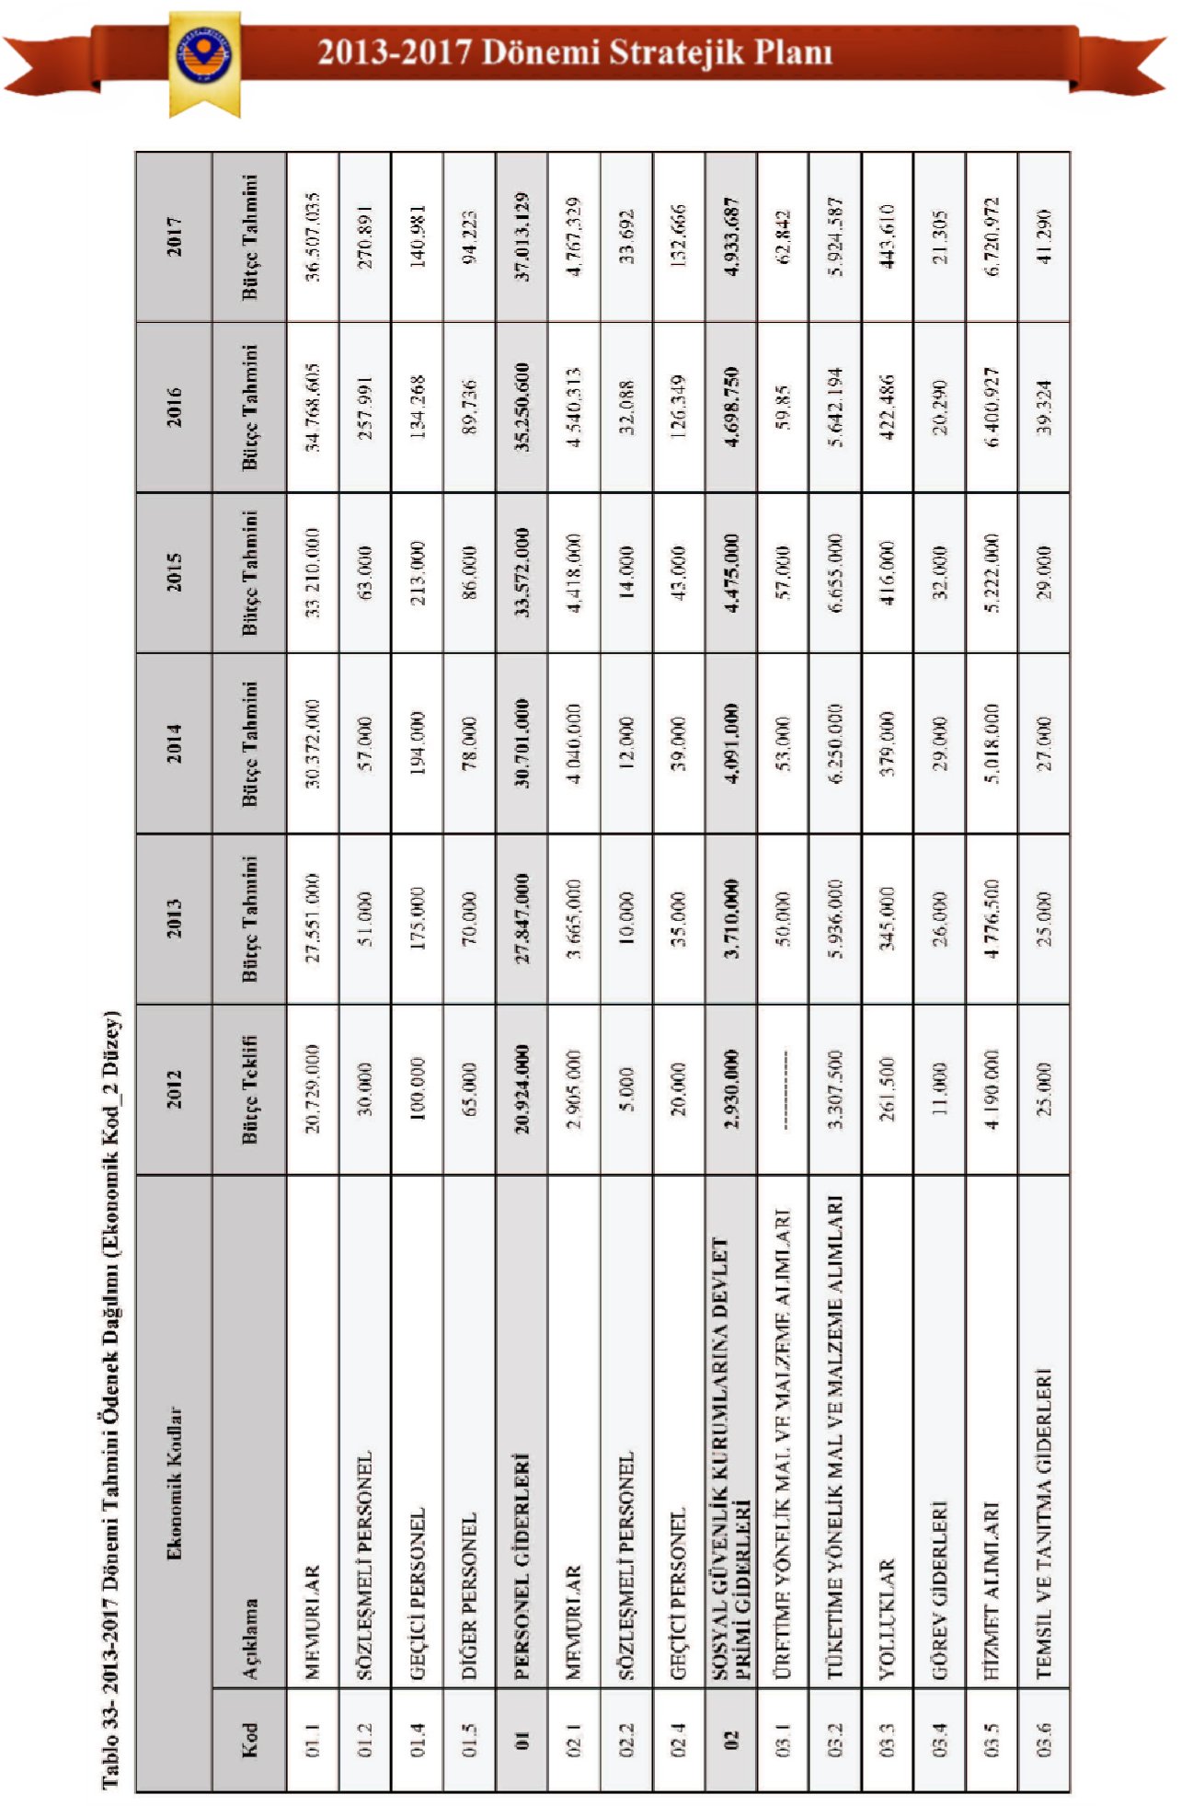

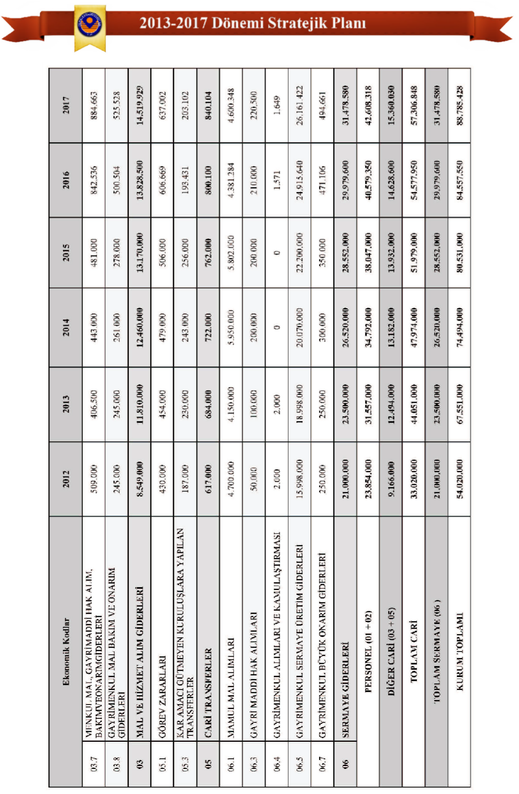

5. MONITORING AND EVALUATION
To ensure the planning and management process is carried out more effectively, monitoring of the implementation and periodic evaluation of the results are necessary. In the subsequent stages, unit representatives and the strategic planning committee will carry out this monitoring and evaluation. This committee will be established as soon as possible, and work will begin on organizing and verifying existing information within the units, creating performance indicators and statistics, and regularly updating the prepared statistics.

The strategic plan will be implemented by academic and administrative units. The monitoring and evaluation process will begin after the strategic plan is approved and put into effect. During this process, units will systematically monitor the progress of strategic goals by preparing reports. In this context, whether or not the goals have been achieved, and to what extent they have been achieved, as well as the consistency of the plan, will be analyzed. Reports will be prepared regularly every year and sent to all units of the university, including senior management.

The Strategic Planning Commission will evaluate the approach taken to achieve the strategic aims and objectives set forth in our university's 2013-2017 strategic plan, the methods used to reach performance targets, and the outputs and results obtained from the activities and projects undertaken. Monitoring and control regarding these targets will be ensured by the identified units responsible for them. If deemed necessary, revisions may be decided upon every two years. Changes identified during the revision process will be incorporated into the plan in coordination with the rectorate, the strategic planning commission, and the relevant units.

5.1
Monitoring and Evaluation Table

Table 34 – Strategic Objectives, Performance Indicators and Responsible Units

SA | SH | Performance Indicators | Responsible Unit | Monitoring and Evaluation | Measurement Time and Interval | Data Source
SA1 | SH1 | PG1-PG4 | OİDB / | Rectorate and Student Affairs Office | Four times a year | Unit/Institution
SA1 | SH1 | PG1-PG4 | Academic Units | Rectorate and Student Affairs Office | Four times a year | Activity Report
SA1 | SH2 | PG5-PG6 | Academic Units | Rectorate and Academic Units | Four times a year | Unit/Institution
 |  |  |  |  |  | Activity Report
SA1 | SH3 | PG7-PG11 | Academic Units | Rectorate and Academic Units | Four times a year | Unit/InstitutionActivity Report
SA2 | SH4 | PG12-P13 | BAP / MER-LAB / GÜN-ORG / IMDB | Rectorate and General Secretariat | Four times a year | Unit/Institution
SA2 | SH4 | PG12-P13 | GUN-SEM / IMIDB | Rectorate and General Secretariat | Four times a year | Activity Report
SA2 | SH5 | PG14-P15 | Academic Units | Rectorate and Academic Units | Four times a year | Unit/InstitutionActivity Report
SA3 | SH6 | PG16-PG17 | Rectorate | Rectorate and General Secretariat | Four times a year | Unit/Institution
SA3 | SH6 | PG16-PG17 | (Private Secretary) | Rectorate and General Secretariat | Four times a year | Activity Report
SA3 | SH6 | PG16-PG17 | IMIDB | Rectorate and General Secretariat | Four times a year
SA4 | SH7 | PG18-PG24 | YITDB | Rectorate and YİTDB | Four times a year | Unit/Institution
 |  |  |  |  |  | Activity Report
SA4 | SH8 | PG25 | YITDB | Rectorate and YİTDB | Four times a year | Unit/InstitutionActivity Report
SA5 | SH9 | PG26-PG28 | PDB | Rectorate, General Secretariat and PDB | Four times a year | Unit/Institution
 |  |  |  |  |  | Activity Report
SA5 | SH10 | PG29-PG33 | IMIDB - SKSDB | Rectorate and IMIDB-SKSDB | Four times a year | Unit/Institution
 |  |  |  |  |  | Activity Report
SA5 | SH11 | PG34-PG35 | General Secretariat Legal Counsel | Rectorate and General Secretariat | Four times a year | Unit/Institution
 |  |  |  |  |  | Activity Report
SA5 | SH12 | PG36-PG40 | BİDB-KDDB | Rectorate and IT Department-KDDB | Four times a year | Unit/Institution
 |  |  |  |  |  | Activity Report
SA5 | SH13 | PG41-PG45 | SKSDB | Rectorate and SKSDB | Four times a year | Unit/Institution
 |  |  |  |  |  | Activity Report
SA5 | SH14 | PG46-PG49 | Rector's Office (Private Secretary) / SKSDB | Rectorate and General Secretariat | Four times a year | Unit/InstitutionActivity Report
SA6 | SH15 | PG50-PG53 | SGDB –DSİM-Internal  Audit Unit | Rectorate and SGDB - Internal Audit Unit | Four times a year | Unit/Institution
 |  |  |  |  |  | Activity Report

6.
BOARDS AND COMMITTEES

Table 35 - Gümüşhane University Academic Evaluation and Quality Development Board (GÜN-ADEK)

Gümüşhane University Strategy Development Board (GÜN-SGK)
Gümüşhane University Academic Evaluation and Quality Development Board (GÜN-ADEK)
Minister | Prof. Dr. İhsan GÜNAYDIN | Rector
Acting President | Prof. Dr. Haydar AKYAZI | Vice Rector / Dean of the Faculty of Economics and Administrative Sciences
Member | Prof. Dr. Celalettin VATANDAŞ | Dean of the Faculty of Communication
Member | Mustafa BAYTAR | Secretary General
Member | Assoc. Prof. Dr. Temel BAYRAK | Director of the Institute of Science
Member | Assoc. Prof. Dr. Orhan KÜÇÜK | Director of the Institute of Social Sciences
Member | Asst. Prof. Dr. Cemalettin BALTACI | Faculty of Engineering / Faculty Member
Member | Asst. Prof. Dr. Mahmut ERDOĞAN | Faculty of Economics and Administrative Sciences / Faculty Member
Member | Asst. Prof. Dr. Hasan GÜLLÜPINAR | Faculty of Communication / Lecturer
Member | Asst. Prof. Dr. Saime ŞAHİNÖZ | Director of the School of Health Sciences
Member | Asst. Prof. Dr. Sedat BOSTAN | Director of Tourism Management and Hotel Management Vocational School
Member | Asst. Prof. Dr. Özgün KALKIŞIM | Director of Gümüşhane Vocational School
Member | Asst. Prof. Dr. Kağan KILINÇ | Director of Health Services Vocational School
Member | Assoc. Prof. Dr. Vecihi AKSAKAL | Director of Kelkit Aydın Doğan Vocational School
Member | Asst. Prof. Dr. Ali Fuat BODUR | Director of Kelkit Health Services Vocational School
Member | Asst. Prof. Dr. Bilge BAHAR | Director of Şiran Mustafa Beyaz Vocational School
Member | Assoc. Prof. Dr. Bahri BAYRAM | Irfan Can Köse, Director of Vocational School
Member | Asst. Prof. Dr. Osman ÜÇÜNCÜ | Director of Kürtün Vocational School
Member | Onur KAYA | Head of Strategy Development Department
Member | Ismail Akçay | President of the Chamber of Commerce and Industry
Member | Yusuf BÜYÜKBAYRAKTAR | President of Gümüşhane Young Businessmen Association
Member | Abdulbaki KARA | Chairman of Gümüşhane Pestil and Köme Producers Association.
Member | Mahmut KOYUN | Student Council Representative

Table 36 - Gümüşhane University Strategic Planning Commission (GÜN-SPK)

Title | Name Surname | Unit | Area of ​​Responsibility
Prof. Dr. | Haydar AKYAZI | Rector's Office / Vice Rector / Dean of the Faculty of Economics and Administrative Sciences | GÜN - SPK Chairman / ADEK Deputy Chairman
Department Head | Onur KAYA | Strategy Development Department | ADEK Member /  Analytical Budgeting Officer, Investment Program Officer
Branch Manager | Atilla DURMAZ | Strategy Development Department | Member of AKIDEK
Branch Manager | Atilla DURMAZ | Strategy Development Department | Strategic Planning Officer Internal Control System Officer
Branch Manager | Atilla DURMAZ | Strategy Development Department | (Administrative Units)
Assistant Professor Dr. | Cemalettin BALTACI | Faculty of Engineering | Member of AKIDEK
Assistant Professor Dr. | Cemalettin BALTACI | Vice Dean | Internal Control System Officer
Assistant Professor Dr. | Cemalettin BALTACI |  | (Academic Units)
Assistant Professor Dr. | Sedat BOSTAN | Tourism Management and Hotel Management Vocational School  / Manager | ADEK Member /
Assistant Professor Dr. | Sedat BOSTAN |  | AKIDEK Coordinator
Assistant Professor Dr. | Yener TOP | Gümüşhane Vocational School / Deputy Director | Member of AKIDEK
Assistant Professor Dr. | Yener TOP | Gümüşhane Vocational School / Deputy Director | Communications and Secretariat Officer
Assistant Professor Dr. | Elif ÇELENK KAYA | Gümüşhane Vocational School | Member of AKIDEK
Assistant Professor Dr. | Elif ÇELENK KAYA | Gümüşhane Vocational School | Survey Studies Coordinator
Assistant Professor Dr. | Afşin Ahmet KAYA | Gümüşhane Vocational School /  Center for Continuing Education Application and Research | Member of AKIDEK
Assistant Professor Dr. | Afşin Ahmet KAYA | (DAY – SEM) Director | SWOT/GZFT Analysis Responsible
Assistant Professor Dr. | Ibrahim TURAN | Health Services Vocational School / Deputy Director | Member of AKIDEK
Assistant Professor Dr. | Ibrahim TURAN | Health Services Vocational School / Deputy Director | Student and Staff Analysis Officer

Table 37 - Academic and Administrative Sciences Evaluation and Quality Improvement Coordination Office (GÜN-AKİDEK)

 | His/Her job | Name Surname | Title | Area of ​​Responsibility | Unit
1 | Coordinator | Sedat BOSTAN | Assistant Professor Dr. | With GÜN-ADEK | School of Tourism Management and Hotel Management
1 | Coordinator | Sedat BOSTAN | TIOYO Director | Ensuring Coordination Between GÜN and AKİDEK | School of Tourism Management and Hotel Management
2 | Member | Cemalettin BALTACI | Assistant Professor Dr. | Academic Units | Faculty of Engineering
 |  |  |  | Internal Control Coordinator | Faculty of Engineering
3 | Member | Atilla DURMAZ | Branch Manager V. | Strategic Planning and | Strategy Development Department
3 | Member | Atilla DURMAZ | Faculty Secretary | Internal Control Coordinator for Administrative Units | Strategy Development Department
4 | Member | Yener TOP | Assistant Professor Dr. | GÜN - AKIDEK Secretariat and Communications Officer | Gümüşhane Vocational School
5 | Member | Afşin Ahmet KAYA | Assistant Professor Dr. | SWOT Analysis and Continuing Education Coordinator | Continuing Education Practice  Research Center
 |  |  |  |  | (DAY – SEM)
6 | Member | Elif ÇELENK KAYA | Assistant Professor Dr. | Survey Studies Coordinator | Gümüşhane Vocational School
7 | Member | Ibrahim TURAN | Lecturer | Student Analysis Officer | Vocational School of Health Services
8 | Member | Tarhan OKAN | Lecturer | Survey Studies | School of Health Sciences
9 | Member | M. Akif MARABAOĞLU | Lecturer | Survey Studies | Faculty of Economics and Administrative Sciences
10 | Member | Hakan SEZEREL | Lecturer | Erasmus-Farabi-Bologna Process | Faculty of Engineering
11 | Member | Ali ÜNAL | Lecturer | Erasmus-Farabi-Bologna Process | Faculty of Engineering
12 | Member | R. Özgür DOĞAN | Lecturer | Erasmus-Farabi-Bologna Process | Faculty of Communication
13 | Member | Taskin KILIC | Lecturer | Continuing Education Coordinator | School of Health Sciences



